# IMPLEMENTATION OF EMPLOYEE SUBSYSTEM FOR REST-ASSURED CARE CENTER

Student Name: Adrian Kwamena Mensah Ackon

Student Number: 77302796

IMPLEMENTATION OF EMPLOYEE SUBSYSTEM FOR REST-ASSURED CARE CENTER 1

Implementation and Testing 6

Tables and Data Implementation 6

Table Structure and Example Data 6

Data Constraints 16

TASK 1. Application Builder 21

Task 2: Apex Reports 27

Task 3: Dashboard 32

Part 2: Report 38

4. Bibliography 41

5. Appendixes 43

**Introduction to the Report**

The Rest-assured Care Foundation is a hospital company that provides medical care to patients of all ages, ranging from elderly patients to patients requiring specialized medical treatments. The foundation operates multiple care centers, which are managed independently by medical directors, and different salaried and hourly staff to provide medical care to patients referred by their own general practitioners and help in the smooth running of the facilities. In addition to medical care, Rest-Assured also provides residential care to patients who are unable to care for themselves at home.

The management of employees is crucial for the effective functioning of any hospital, and the Rest-Assured Care Foundation is no exception. In this paper, we will focus on the employee subsection of the Rest-assured Care Foundation's database system, which is responsible for tracking employee information and is being used to build an HR dashboard application.

The employee/staff subsection of the information system contains several tables that store important employee information. This information, which can be found in the table below, is critical for managing the organization's workforce, ensuring that employees are properly compensated, and providing appropriate benefits. The HR-like dashboard application being developed will use this information to provide a central location for employees and managers to access important HR-related information and reports.

Additionally, this paper will consider the potential benefits and drawbacks of using both relational and non-relational database approaches in managing employee data and identify areas in emerging other database concepts that could be useful for supporting data analytics in the employee database system. Finally, we will discuss concerns about how these database technologies may influence the Rest-assured Care Foundation's database technology solutions in the future and consider potential strategies for addressing these concerns.

|  |  |  |  |  |  |  |  |  |  |  |
| --- | --- | --- | --- | --- | --- | --- | --- | --- | --- | --- |
| **RELATION NAME** | **ATTRIBUTES** | | | | | | | | | |
| EMPLOYEE | **emp_id** | *center_id* | phone_no | name | address | Staff_category | job_type | gender | email | dob |
| DOCTOR | **doctor_id** | *salaried_staff_id* | specialization | years_of_experience | license_number | date_of_last_certification |  |  |  |  |
| MEDICAL_DIRECTOR | **md_id** | *salaried_staff_id* | *doctor_id* | appointment_date | end_date | Date_of_employment | Date_of_leaving | Reason_for_leaving |  |  |
| NURSE | **nurse_id** | *salaried_staff_id* | license_number | nurse_type | years_of_experience | Date_of_employment | Date_of_leaving | Reason_for_leaving |  |  |
| ADMINISTRATIVE_STAFF | **admin_staff_id** | *salaried_staff_id* | job_title | job_description | department | Date_of_employment | Date_of_leaving | Reason_for_leaving |  |  |
| SALARIED_STAFF | **salaried_staff_id** | *emp_id* | holiday_rights | pension_rights | salary | Date_of_employment | Date_of_leaving | Reason_for_leaving |  |  |
| HOURLY_STAFF | **hourly_staff_id** | *emp_id* | holiday_rights | pension_rights | hourly_rate | Date_of_employment | Date_of_leaving | Reason_for_leaving |  |  |
| ANCILLARY_STAFF | **ancillary_staff_id** | *hourly_staff_id* | job_title | department | job_responsibility | Date_of_employment | Date_of_leaving | Reason_for_leaving |  |  |
| PORTER | **porter_id** | *hourly_staff_id* | job_title | job_responsibility | Date_of_employment | Date_of_leaving | Reason_for_leaving |  |  |  |
| CLEANER | **cleaner_id** | *hourly_staff_id* | job_title | job_responsibility | Date_of_employment | Date_of_leaving | Reason_for_leaving |  |  |  |

Table 1: Selected tables from Assessment 1

Below are the relations selected for the implementation of the application. In the application, they are preceded by “A2_”.Below is the Extended Entity Relationship Diagram from which the tables above were selected and are being implemented in the application building for this paper.

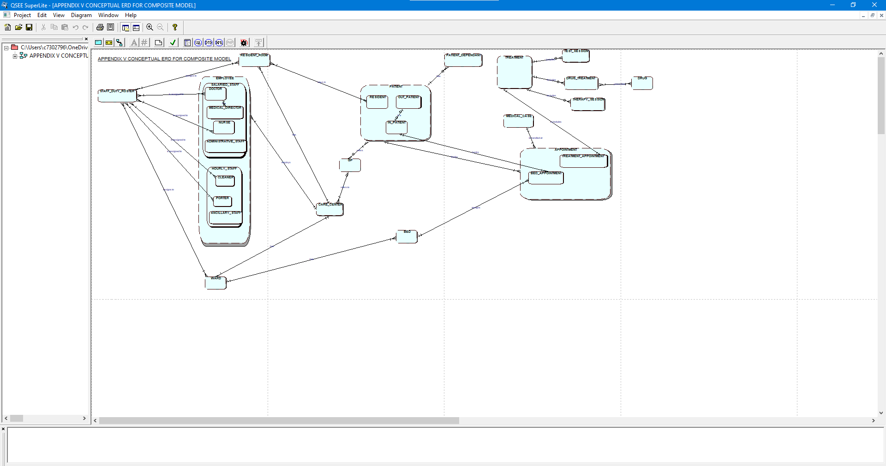

ENTITIES

SELECTED

TO BE USED

## Implementation and Testing

## Tables and Data Implementation

## Table Structure and Example Data

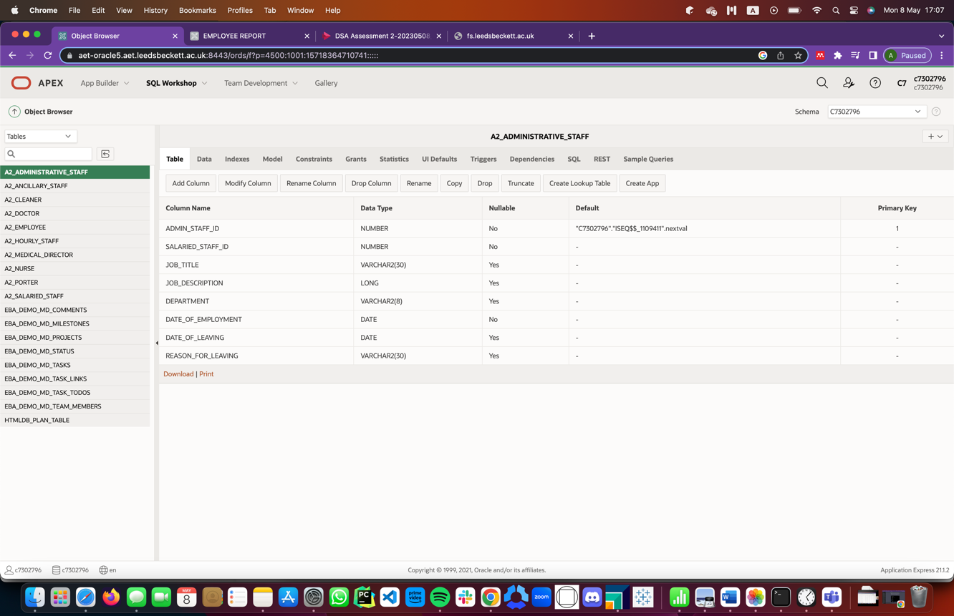

Figure 1: Table 1 (A2_Administrative_Staff)

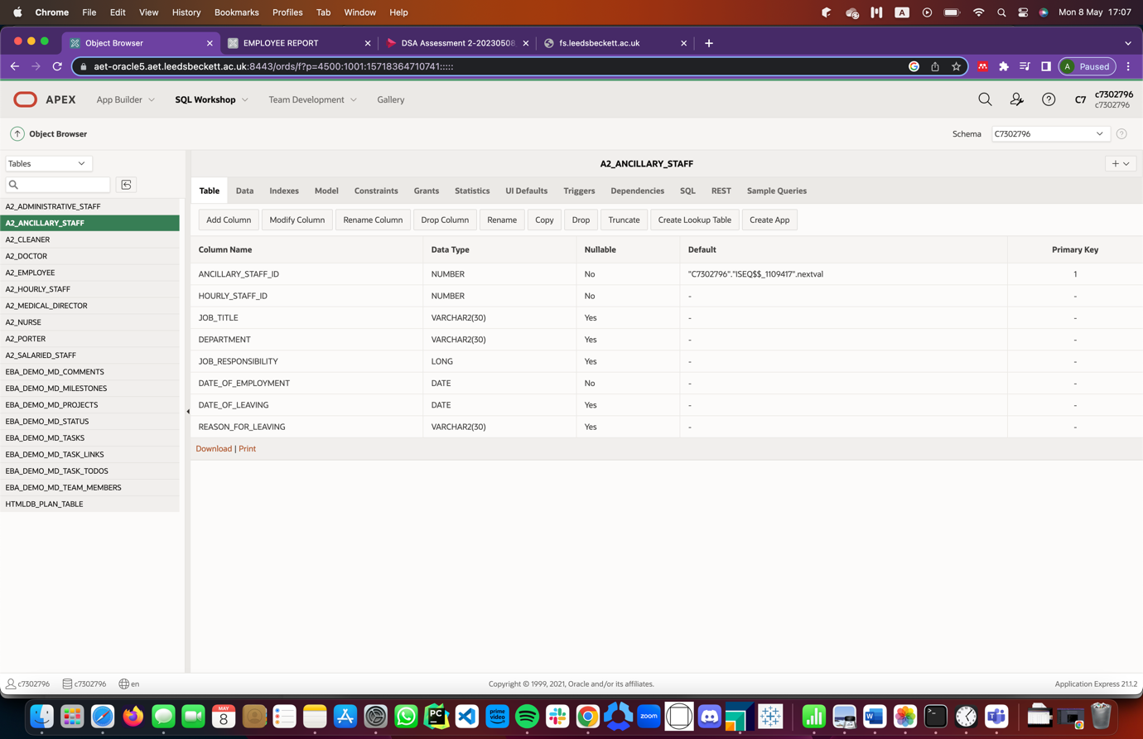

Figure 2: Table 2 (A2_ANCILLARY_STAFF)

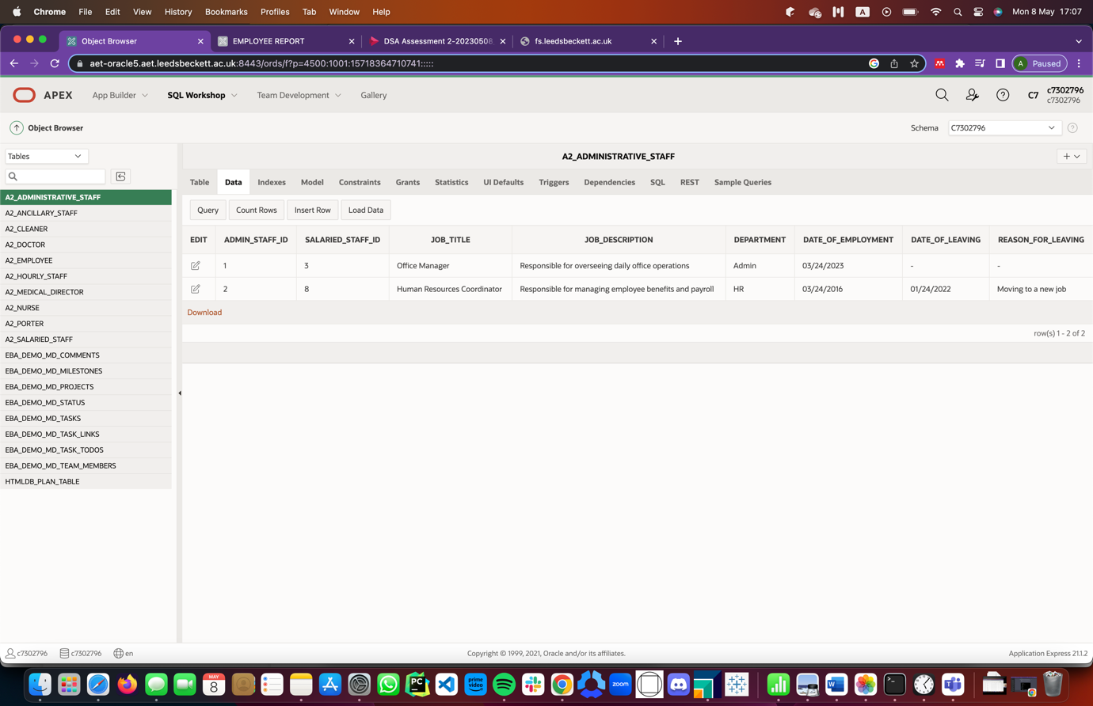

Figure 3: Table 1 (A2_ADMINISTRATIVE_STAFF) Data

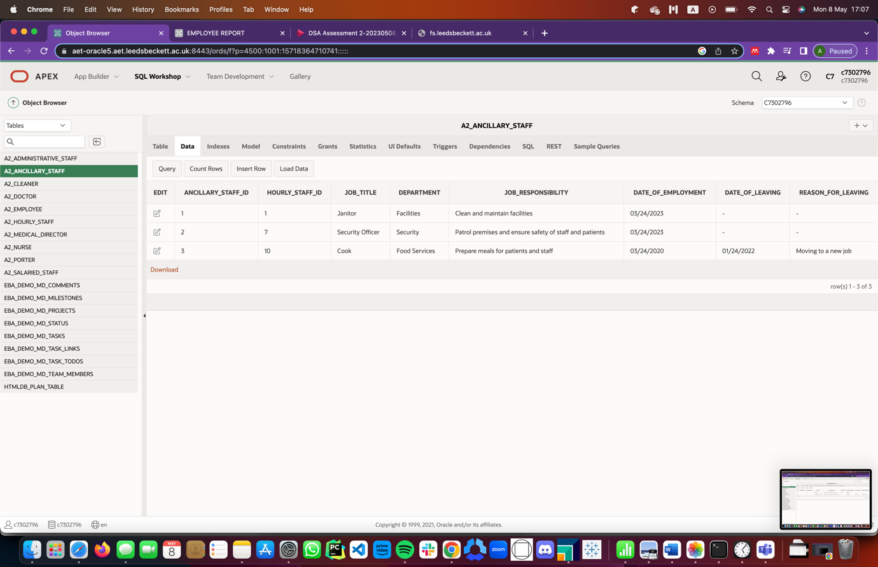

Figure 4: Table 2 (A2_ANCILLARY_STAFF) Data

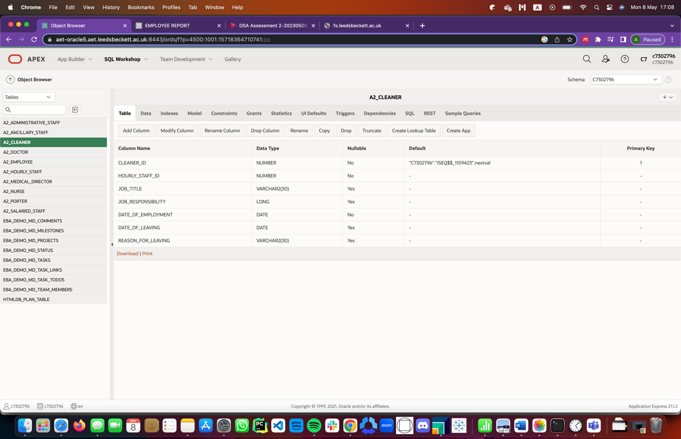

Figure 5: Table 3 (A2_CLEANER)

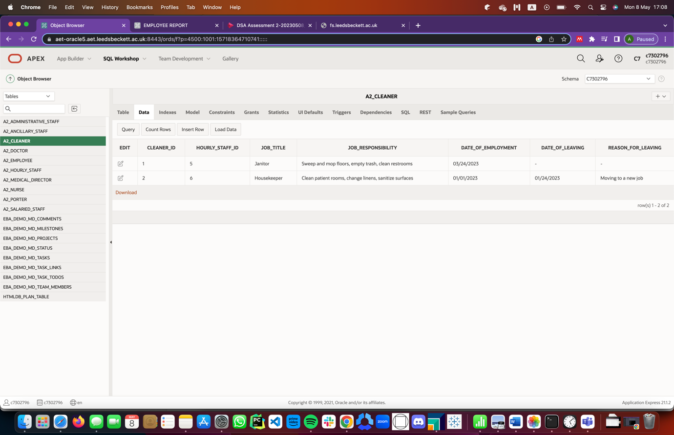

Figure 6: Table 3 (A2_Cleaner) Data

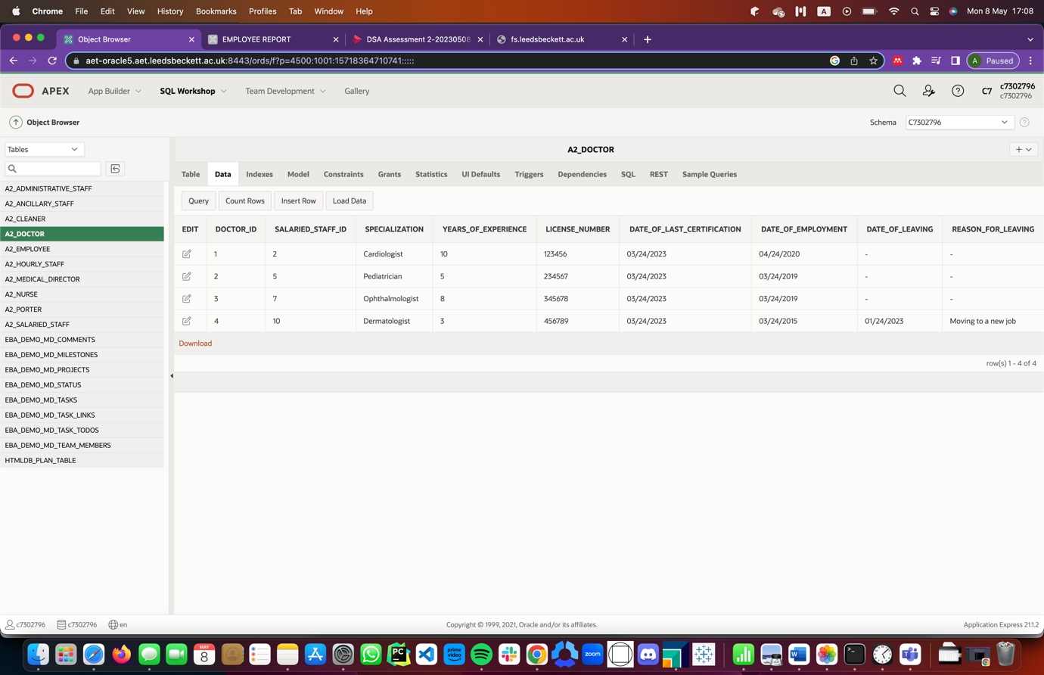

Figure 7: Table 4 (A2_DOCTOR) Data

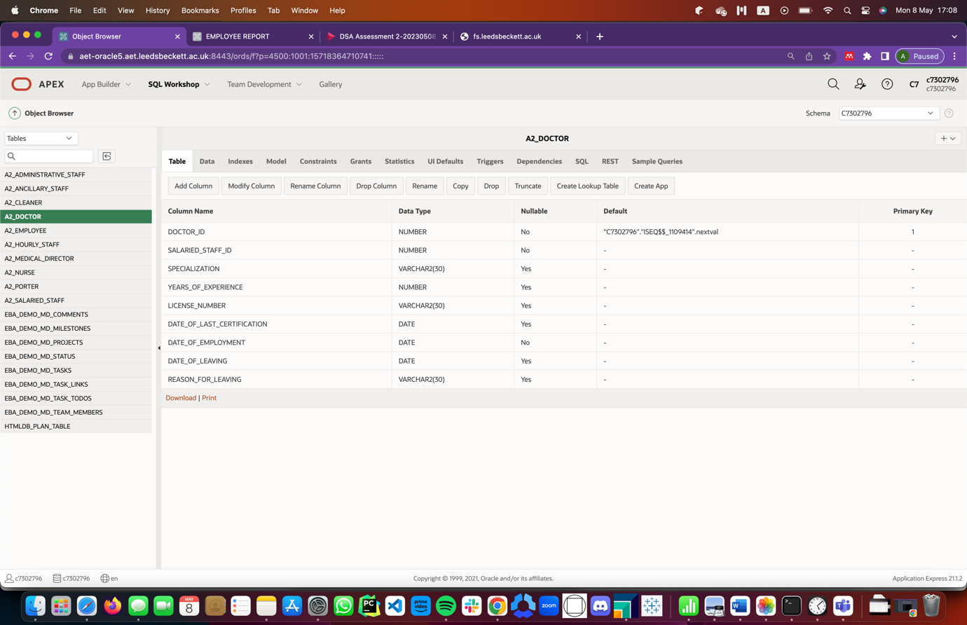

Figure 8: Table 4 (A2_DOCTOR)

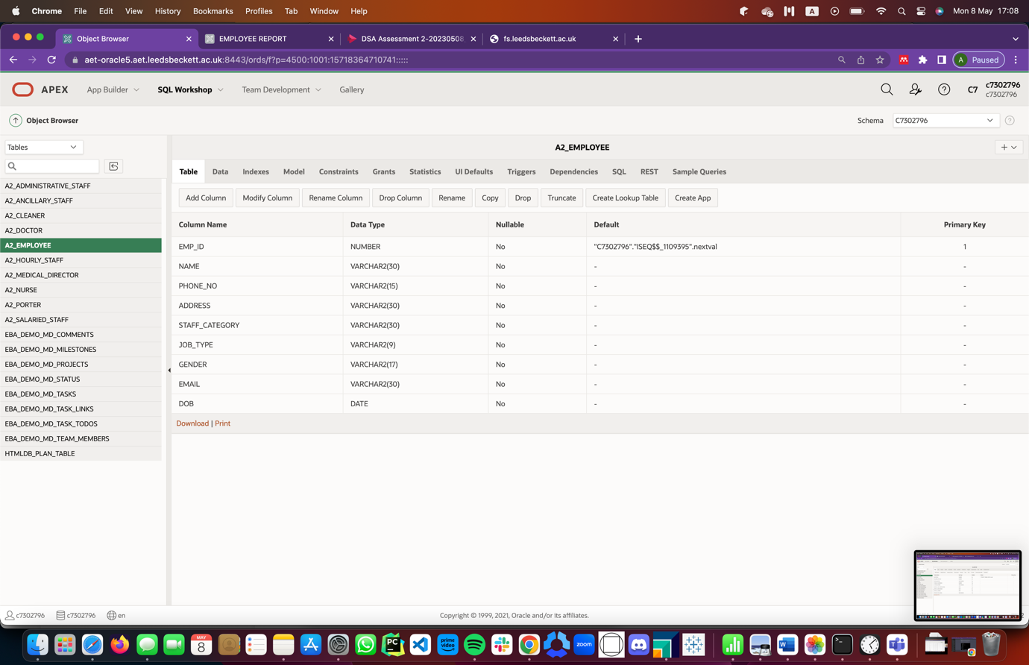

Figure 9: Table 5 (A2_EMPLOYEE)

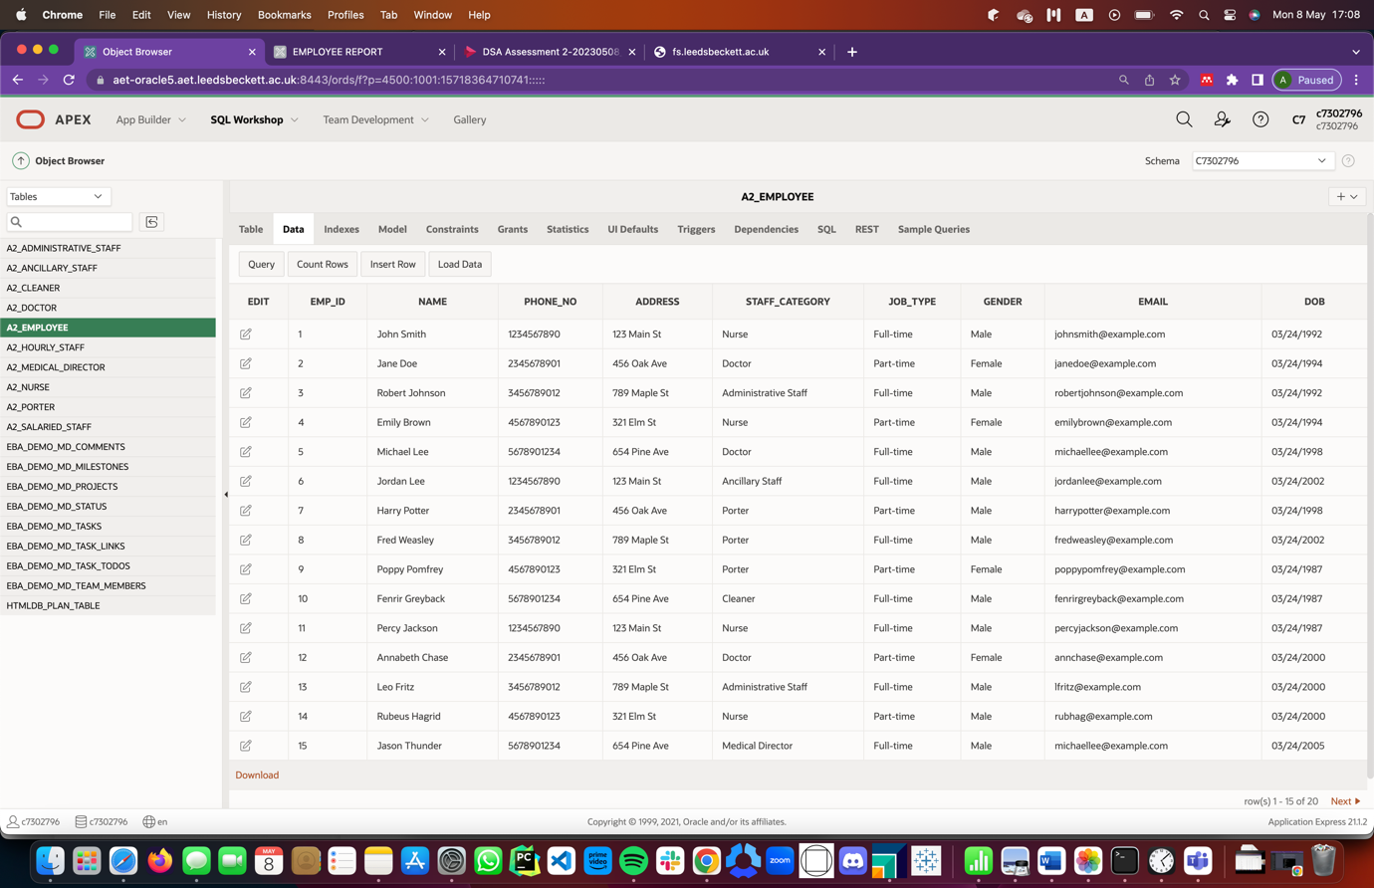

Figure 10: Table 5 (A2_EMPLOYEE) Data

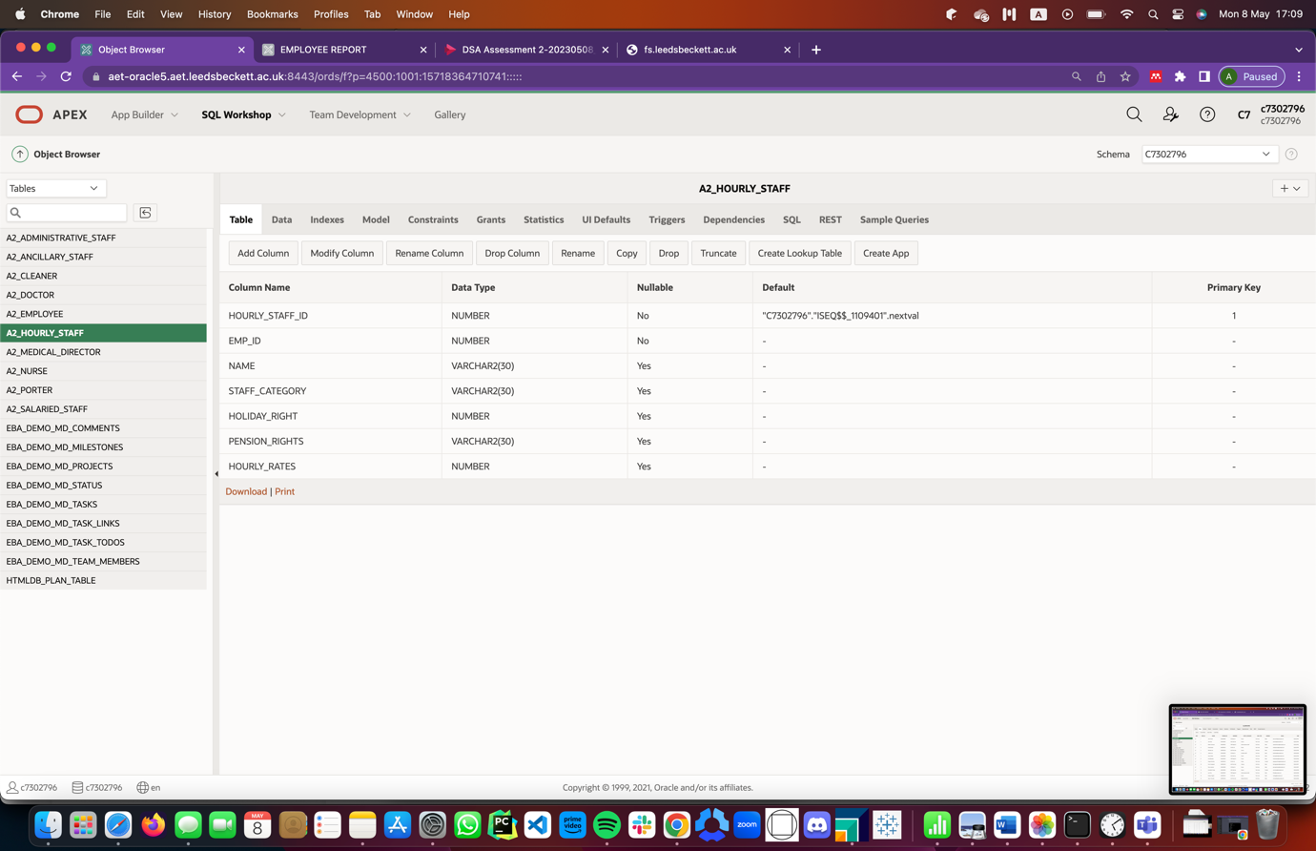

Figure 11: Table 6 (A2_HOURLY_EMPLOYEE)

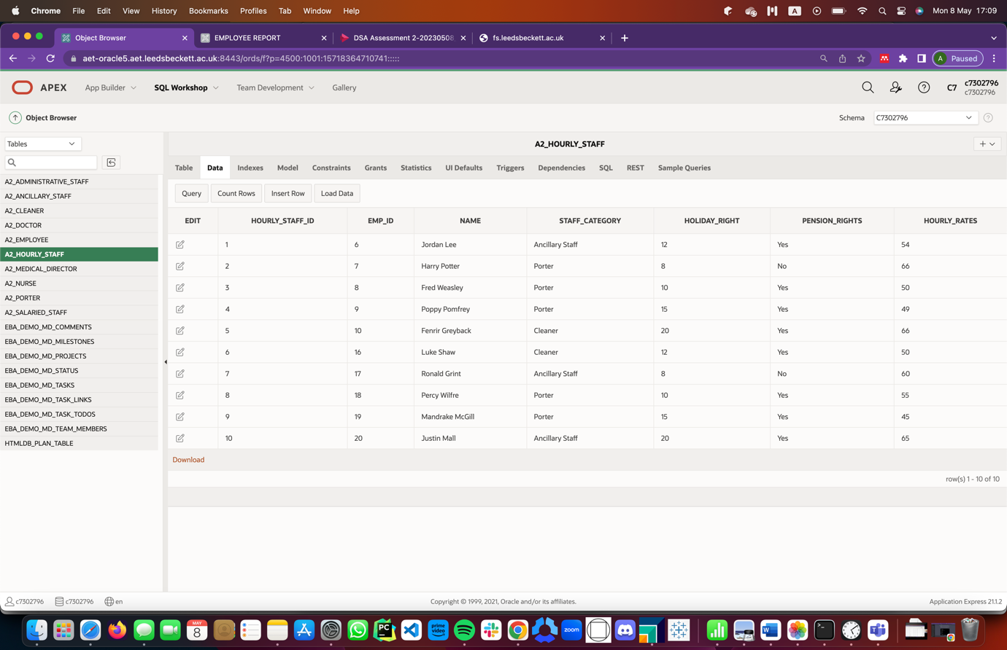

Figure 12: Table 6 (A2_HOURLY_EMPLOYEE) Data

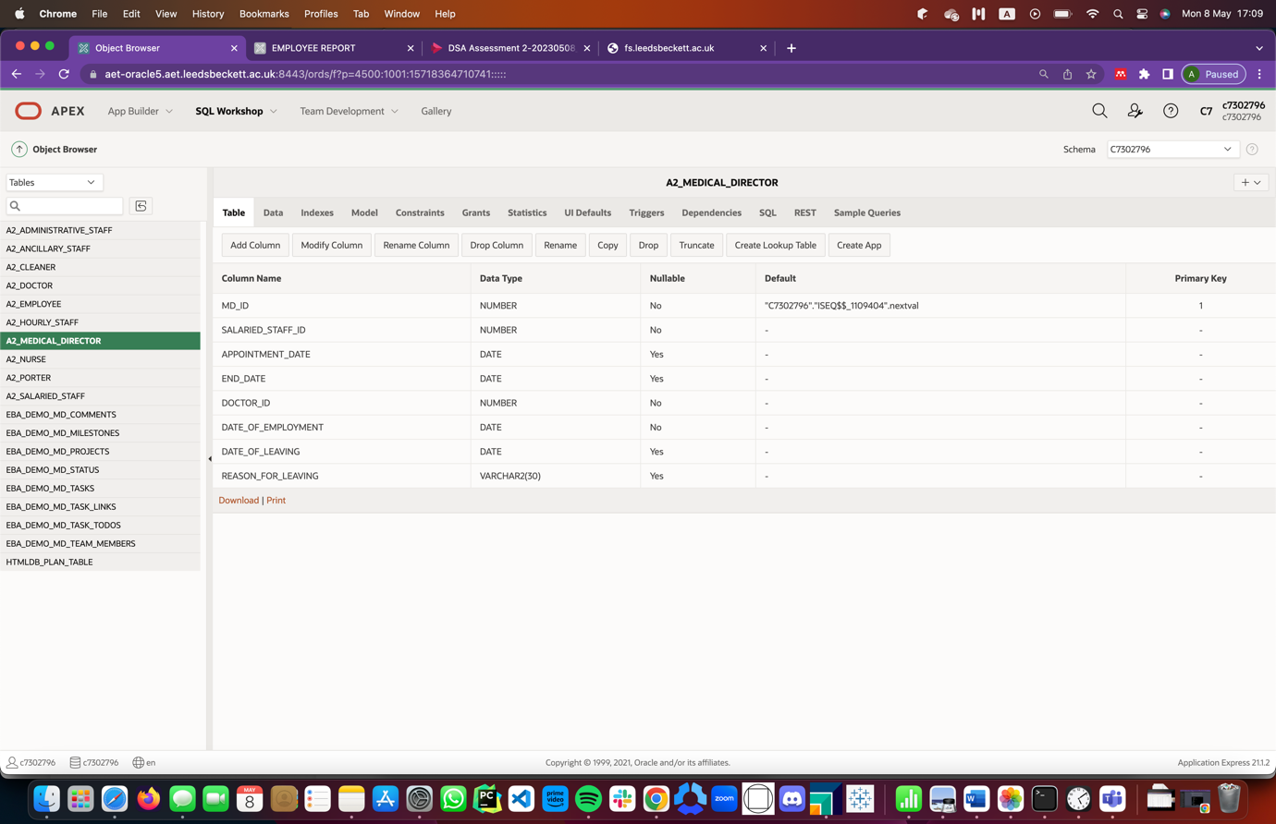

Figure 13: Table 7 (A2_MEDICAL_DIRECTOR)

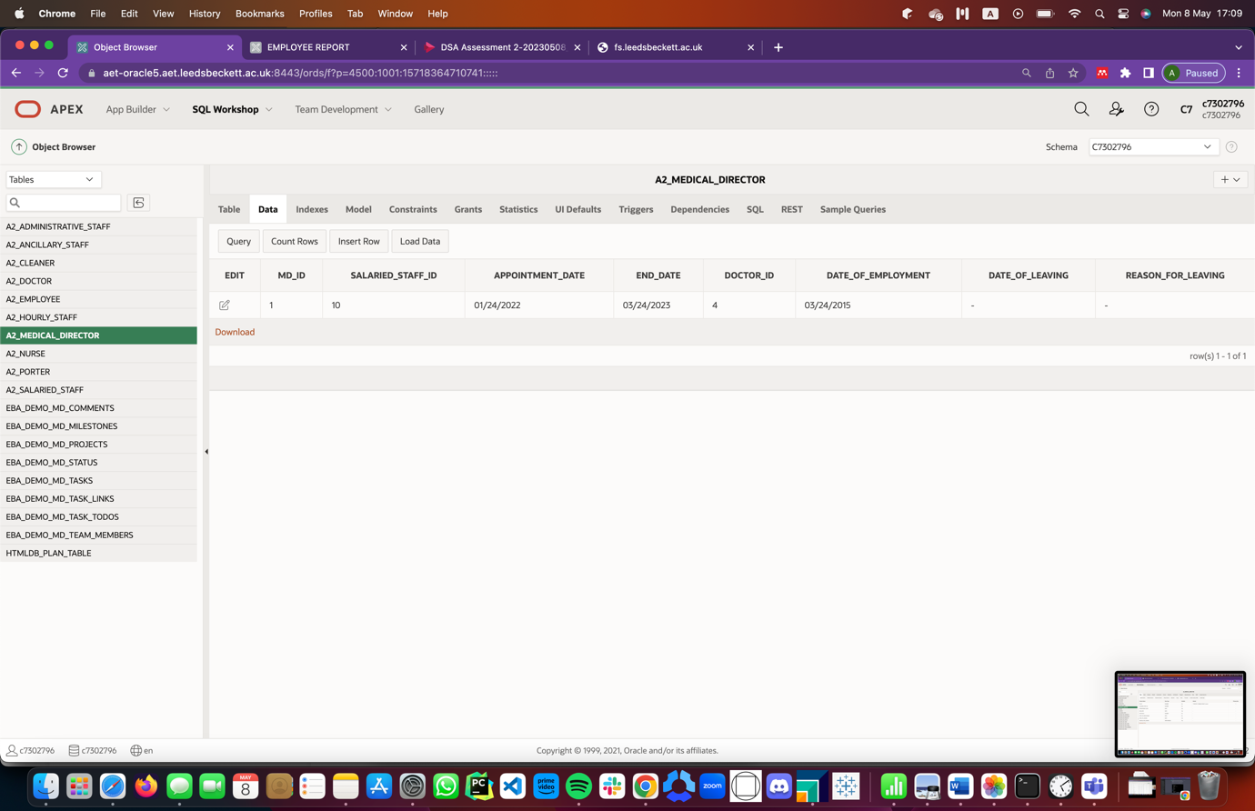

Figure 14: Table 7 (A2_MEDICAL_DIRECTOR) Data

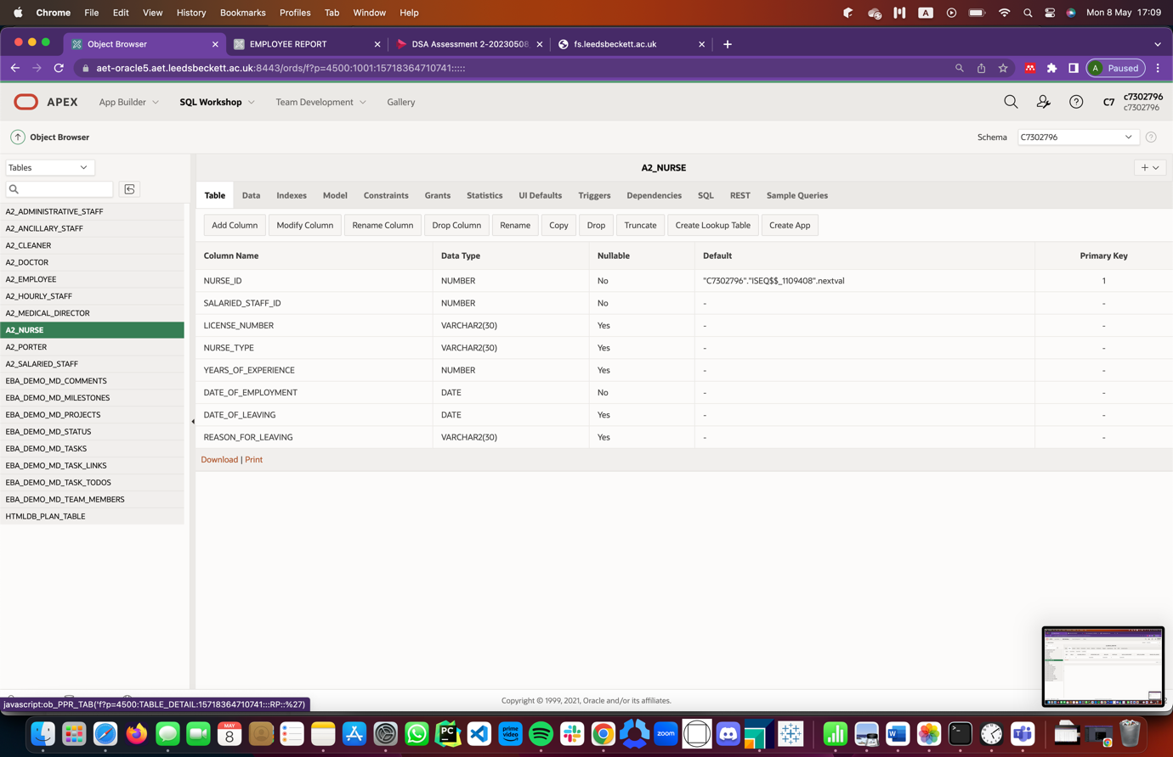

Figure 15: Table 8 (A2_NURSE)

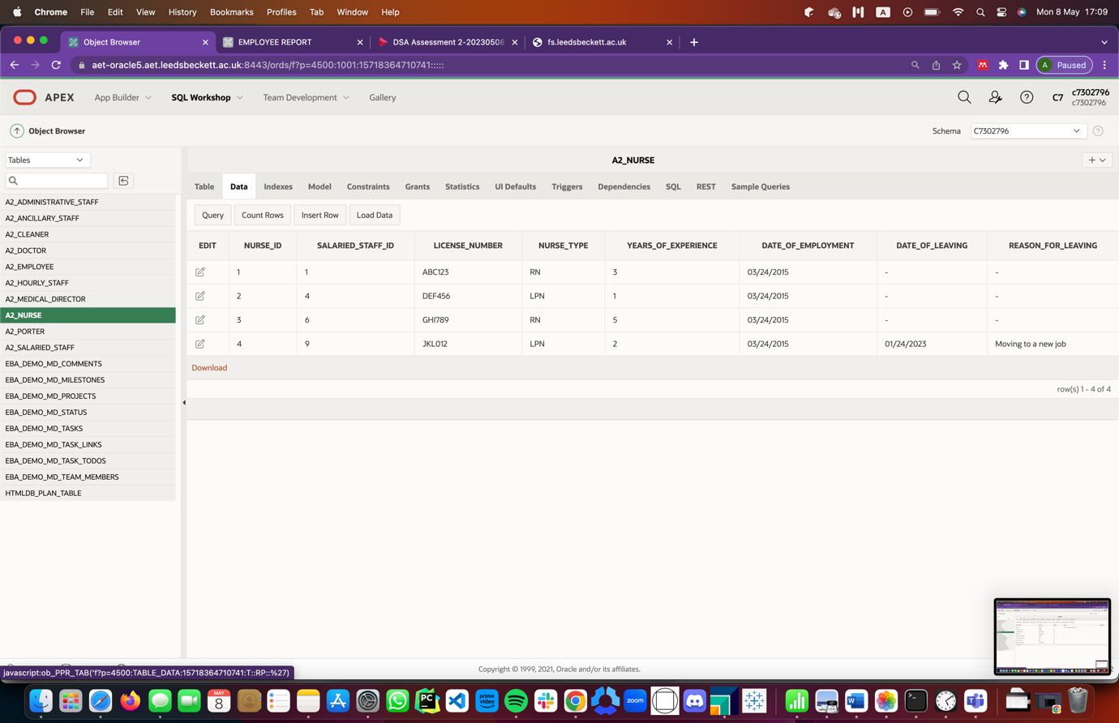

Figure 16: Table 8 (A2_NURSE) Data

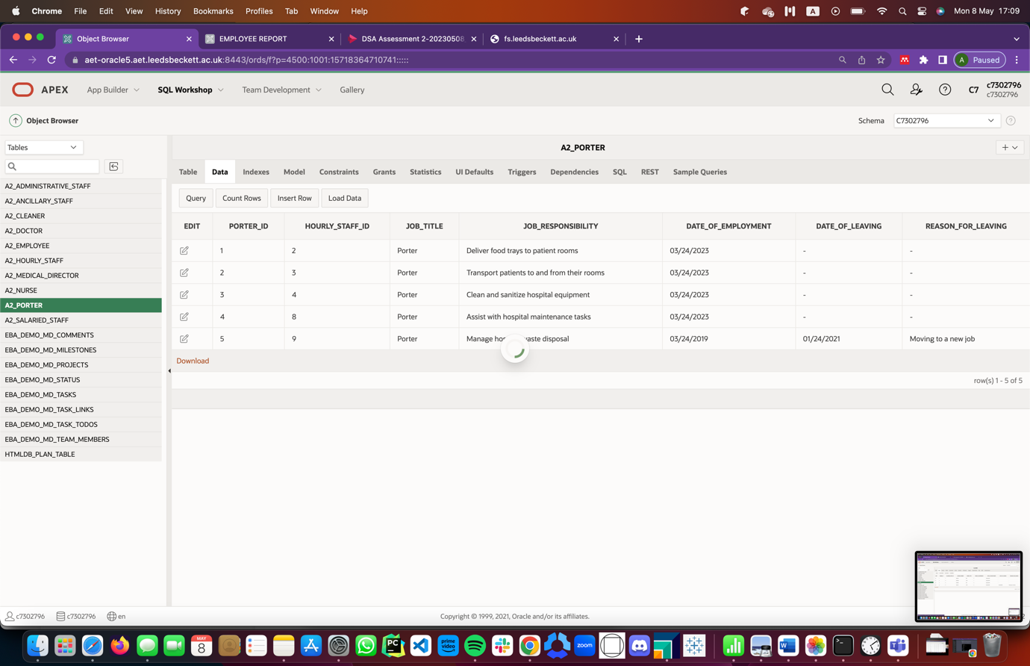

Figure 17: Table 9 (A2_PORTER) Data

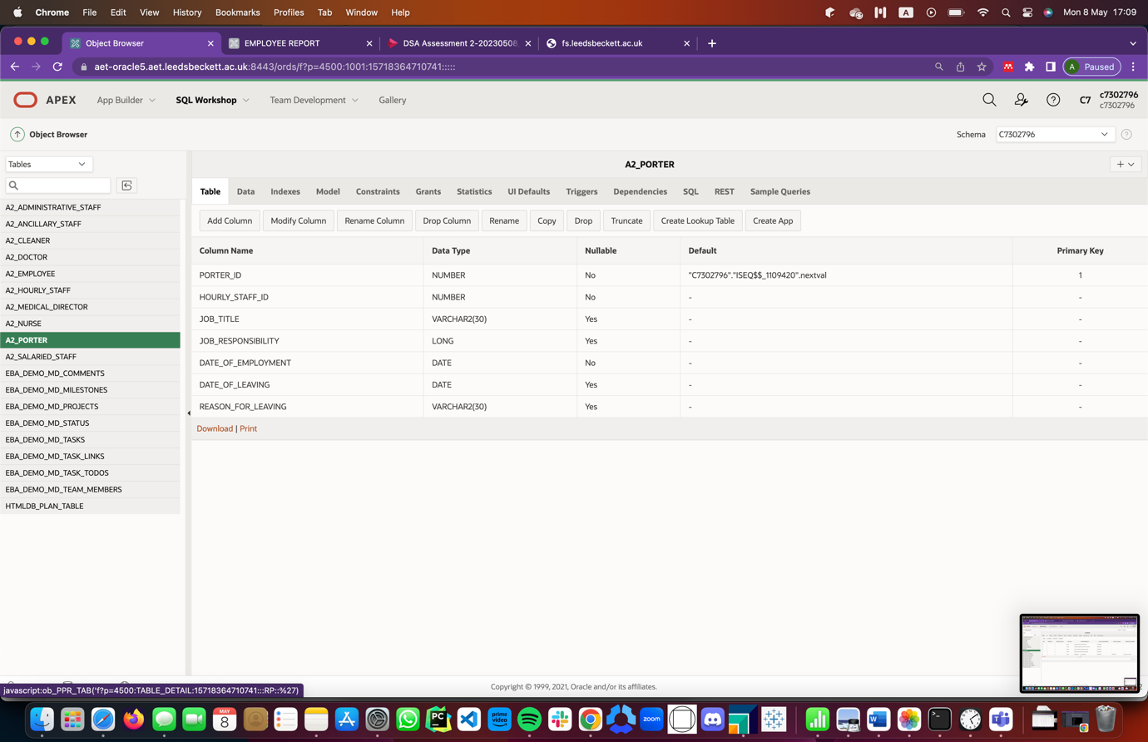

Figure 18: Table 9 (A2_PORTER)

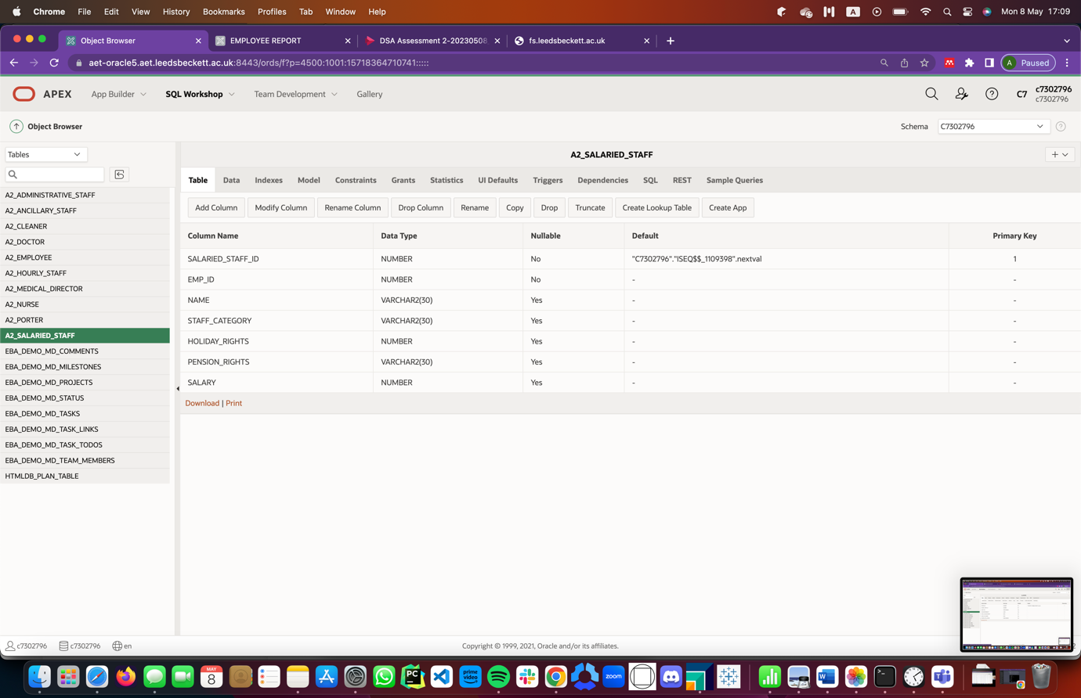

Figure 19: Table 9 (A2_SALARIED_STAFF)

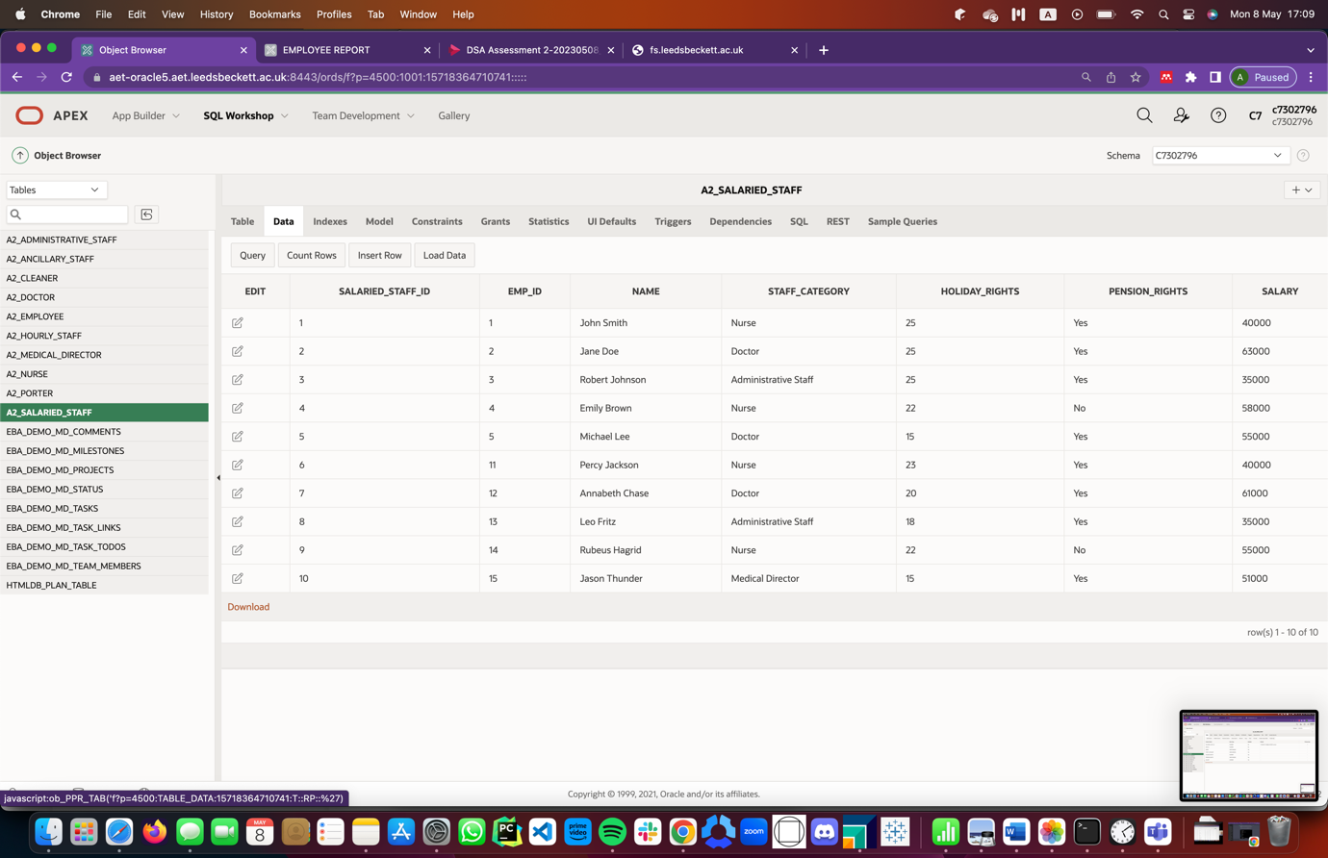

Figure 20: Table 9 (A2_SALARIED_STAFF) Data

## Data Constraints

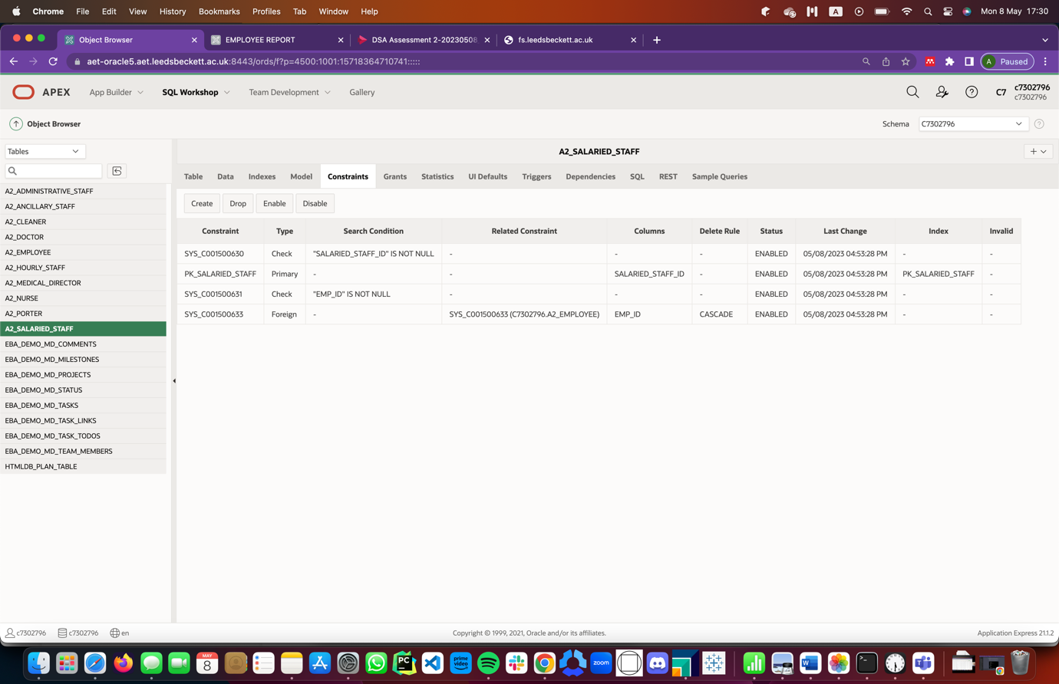

Figure 21: A2_SALARIED_STAFF Constraints

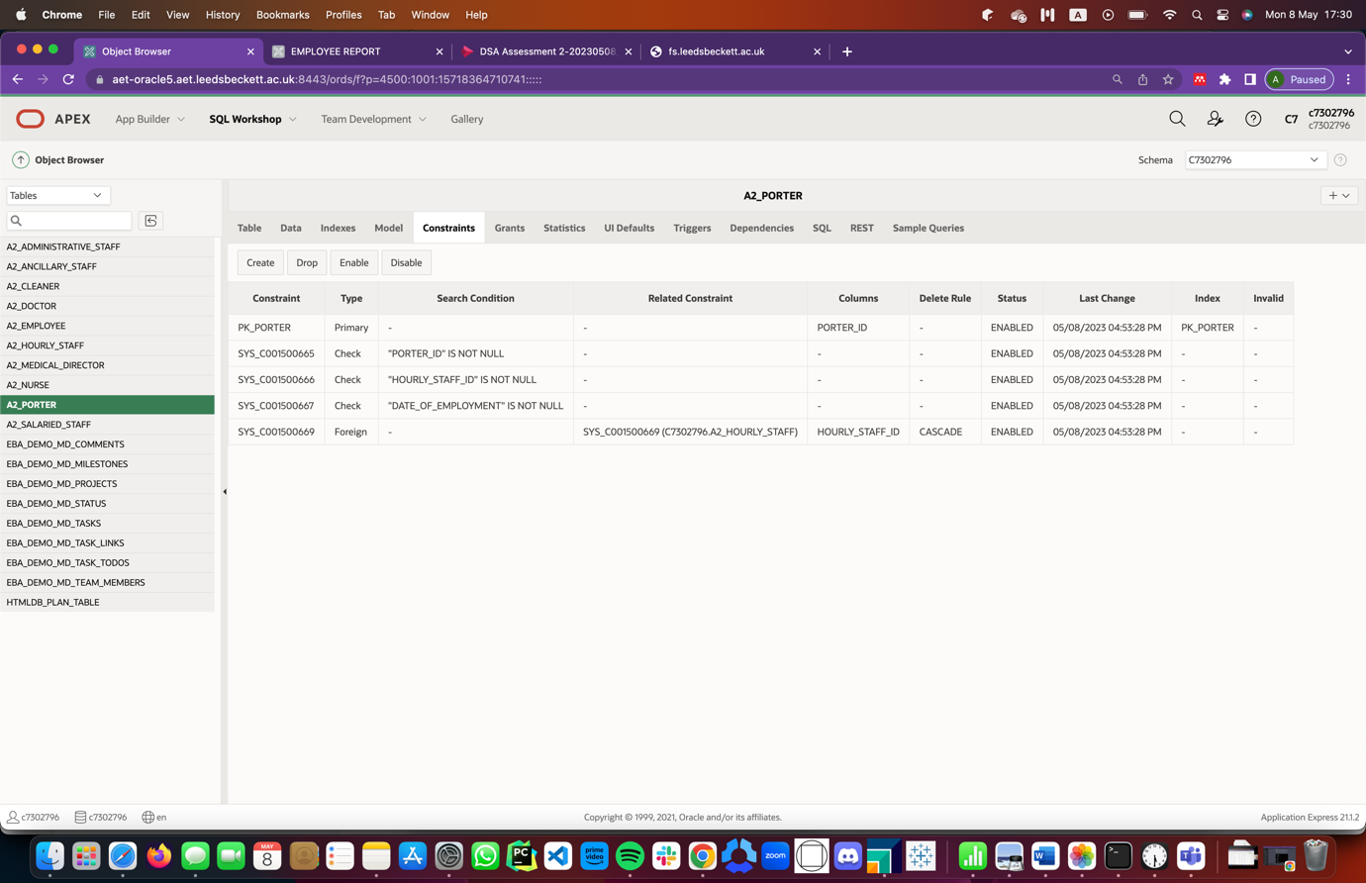

Figure 22: A2_PORTER Constraints

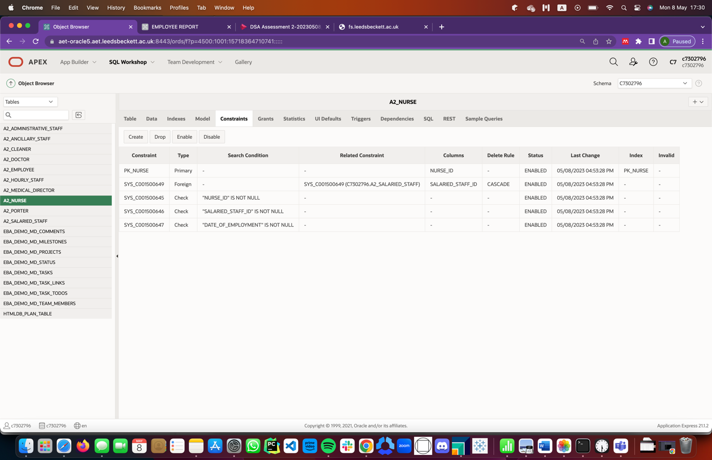

Figure 23: A2_NURSE Constraints

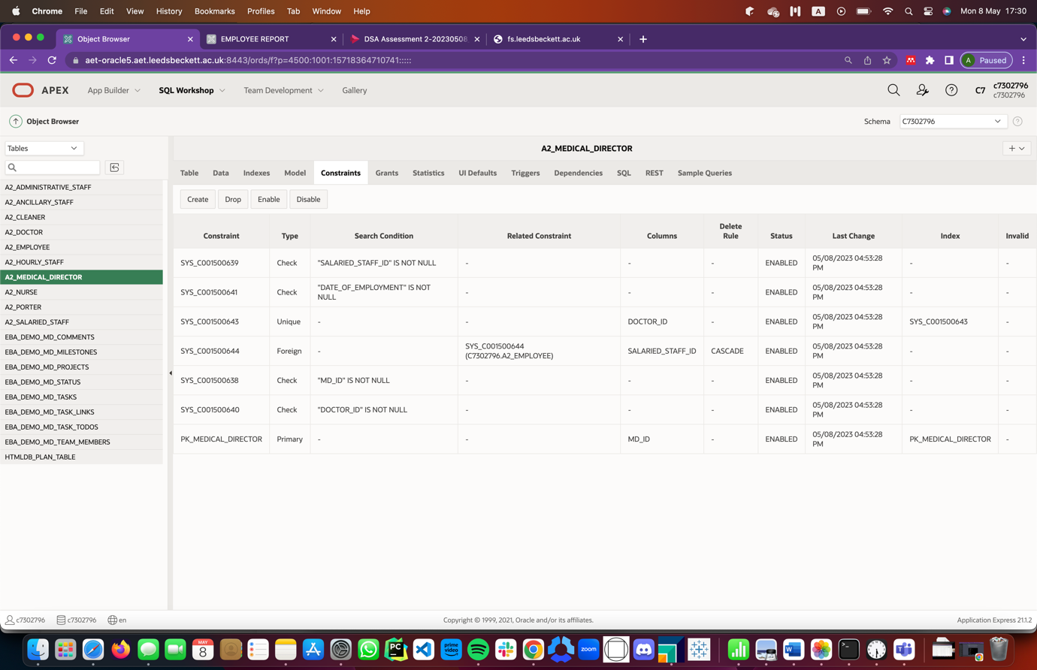

Figure 24: A2_MEDICAL_DIRECTOR Constraints

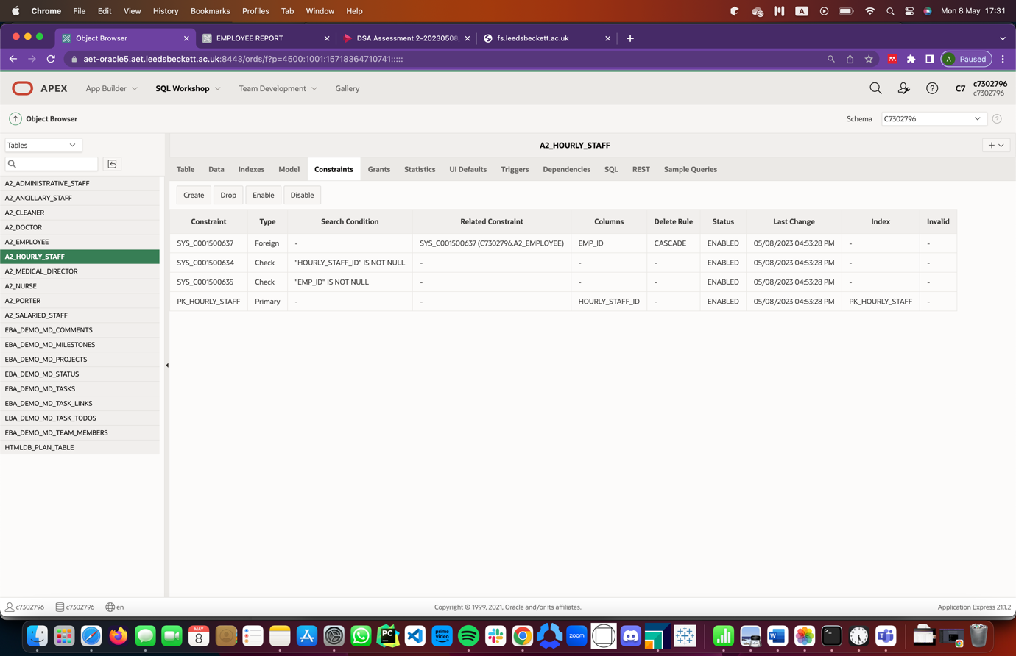

Figure 25: A2_HOURLY_STAFF Constraints

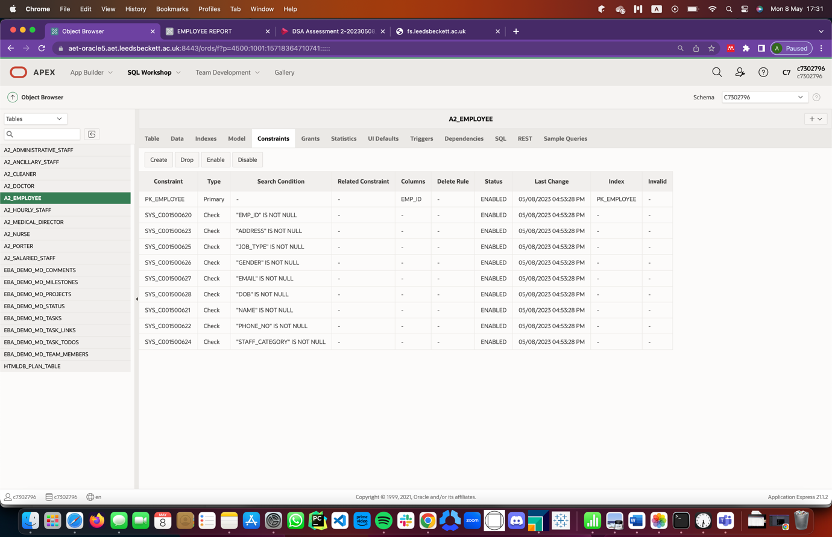

Figure 26: A2_EMPLOYEE Constraints

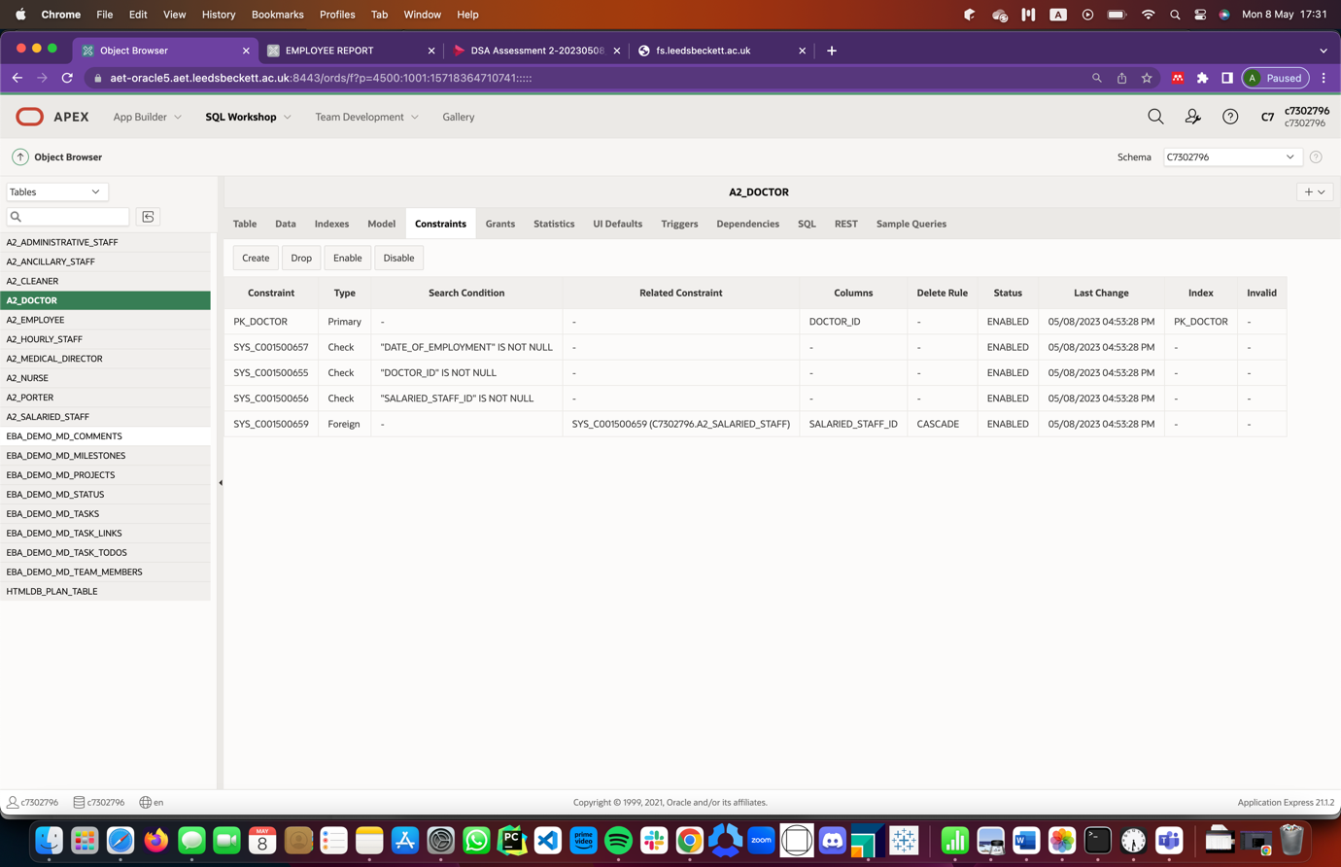

Figure 27: A2_DOCTOR Constraints

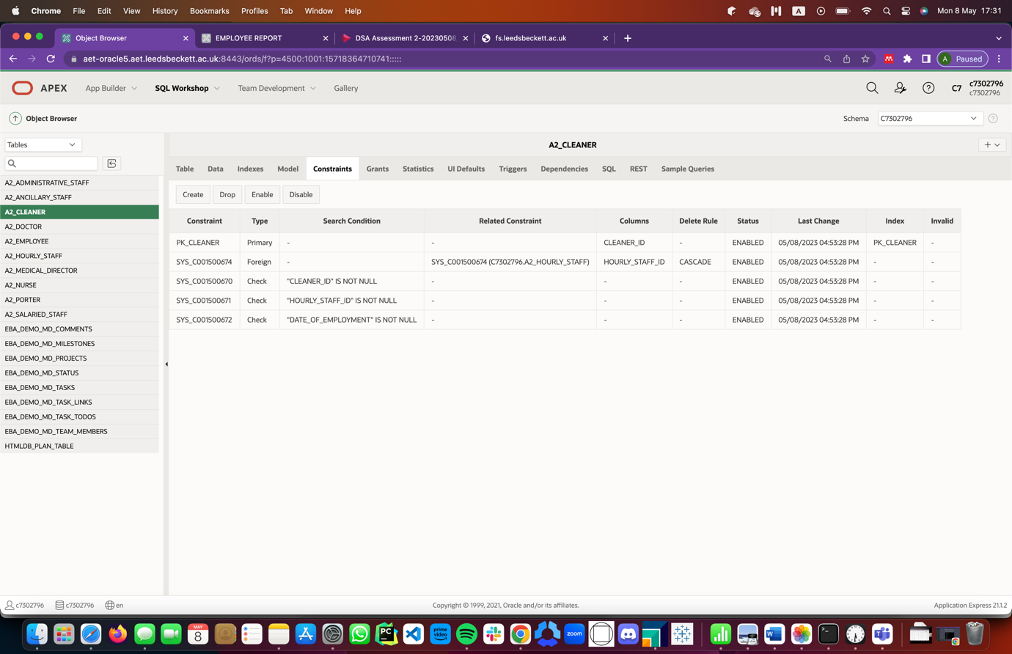

Figure 28: A2_CLEANER Constraints

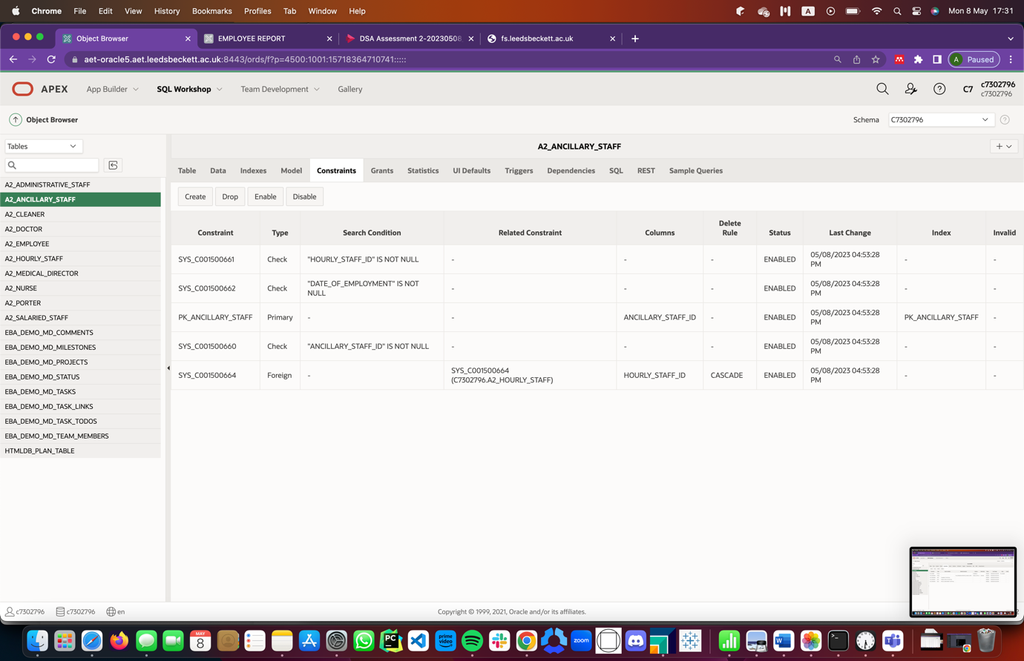

Figure 29: A2_ANCILLARY_STAFF Constraints

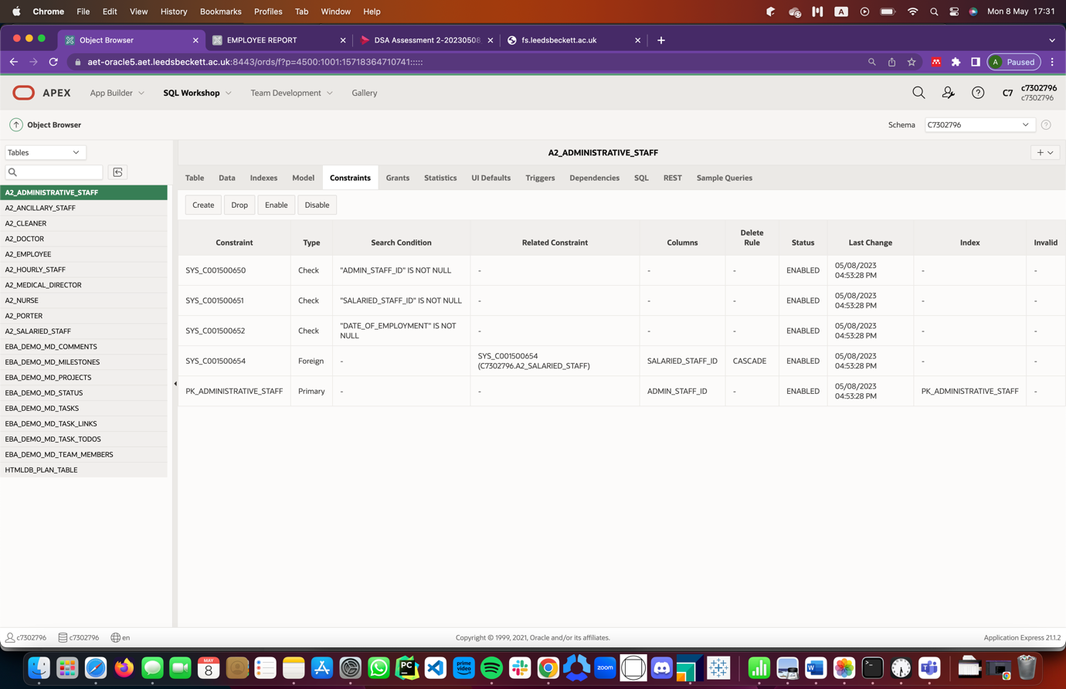

Figure 30: A2_ADMINISTRATIVE_STAFF Constraints

## TASK 1. Application Builder

This application is being built to support the Human Resource (HR) team of Rest-Assured Care Center to manage and view employee data in various forms such as charts, reports and forms. Below are some screenshots of the application with accompanying descriptions for each.

#### Forms

Three (3) master-detail forms were designed for this application: Employee Details; Salaried Staff Details; Hourly Staff Details. The purpose of these forms was to enable the HR team, or User of the Application, to effectively create, update and delete employee records.

To create a record, a User of the application with the right privileges will have to create an employee record in the Employee details form, then based on the staff category, create a corresponding salaried staff or hourly staff record in the same form. After doing this, the User will then have to move to the corresponding form, either Salaried Staff or Hourly Staff Details form, then select the record just created, after which the User will create the corresponding record for the staff category as a detail record on the form page.

To update a record, you just need to click on the edit button which could be found beside all records, then you update the field you desire as a User to update.

To delete a record, if it is to delete the entire employee’s record, you need to delete the record in the master section of the Employee Details Form but if it is just to delete and update at any point, you could delete where necessary.

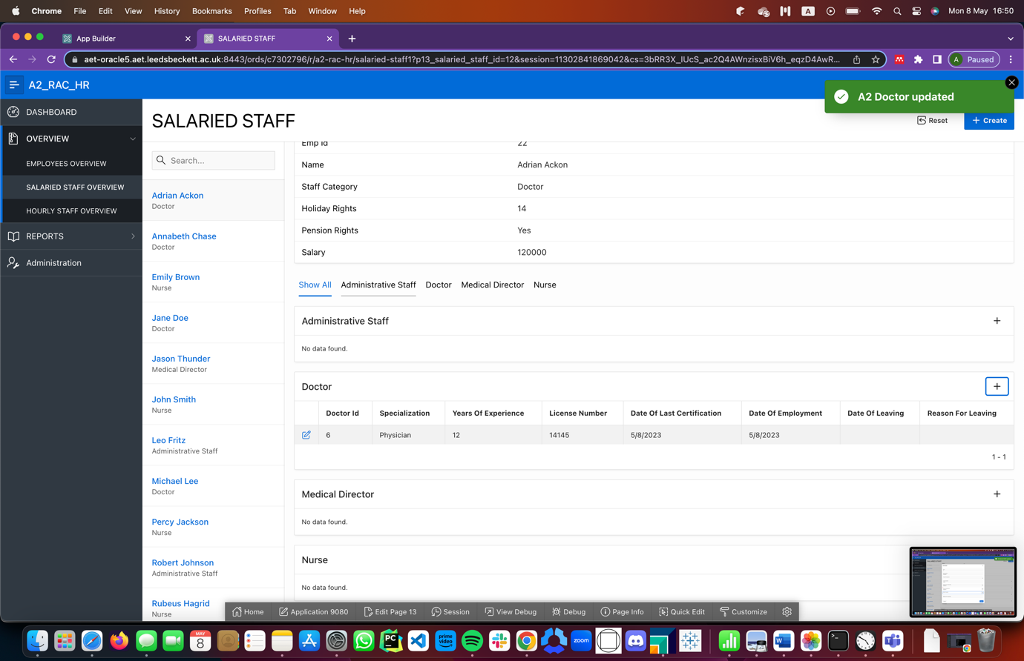

Figure 31: Salaried Staff Master Detail

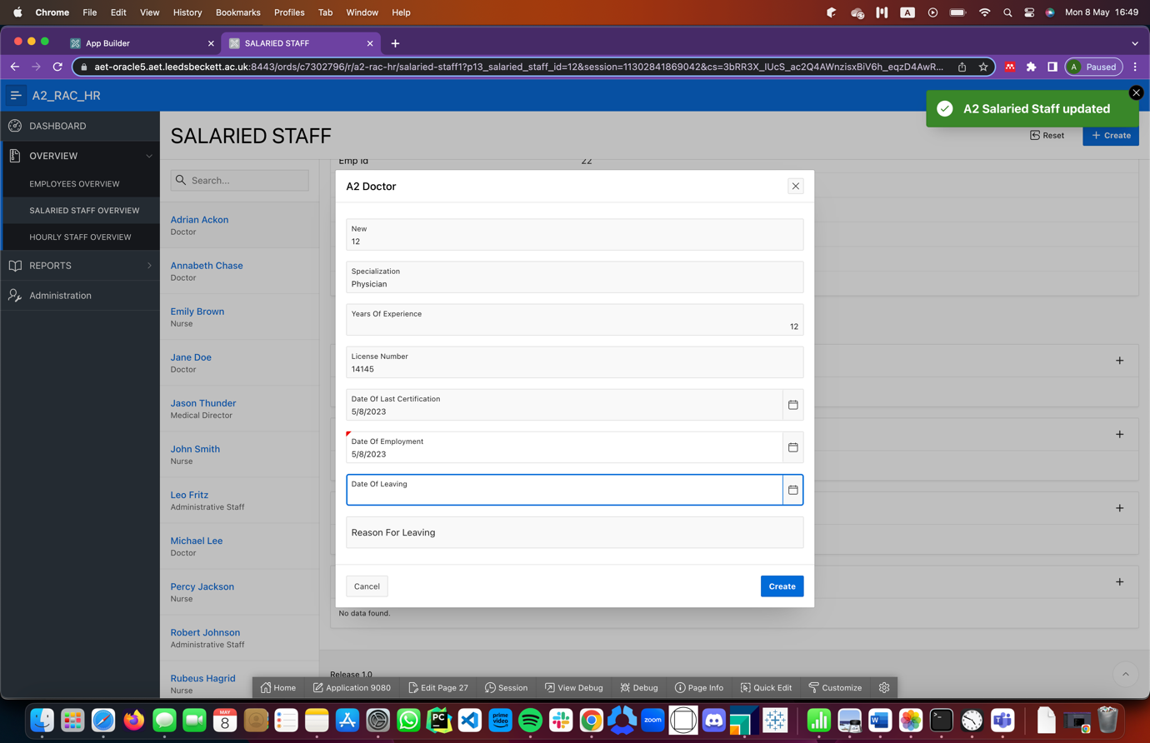

Figure 32: Creating a record for the detail table of Salaried Staff, Doctor

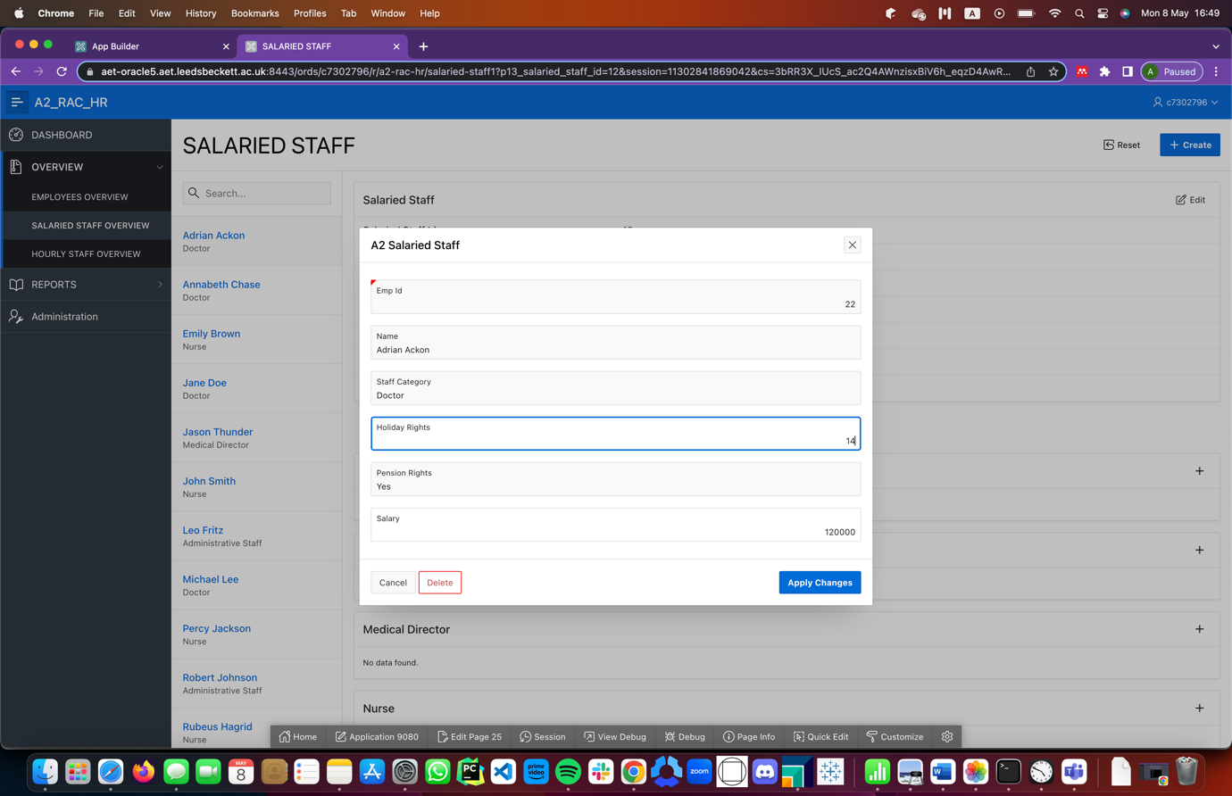

Figure 33: Creating a record for the detail table of the Employee, Salaried Staff

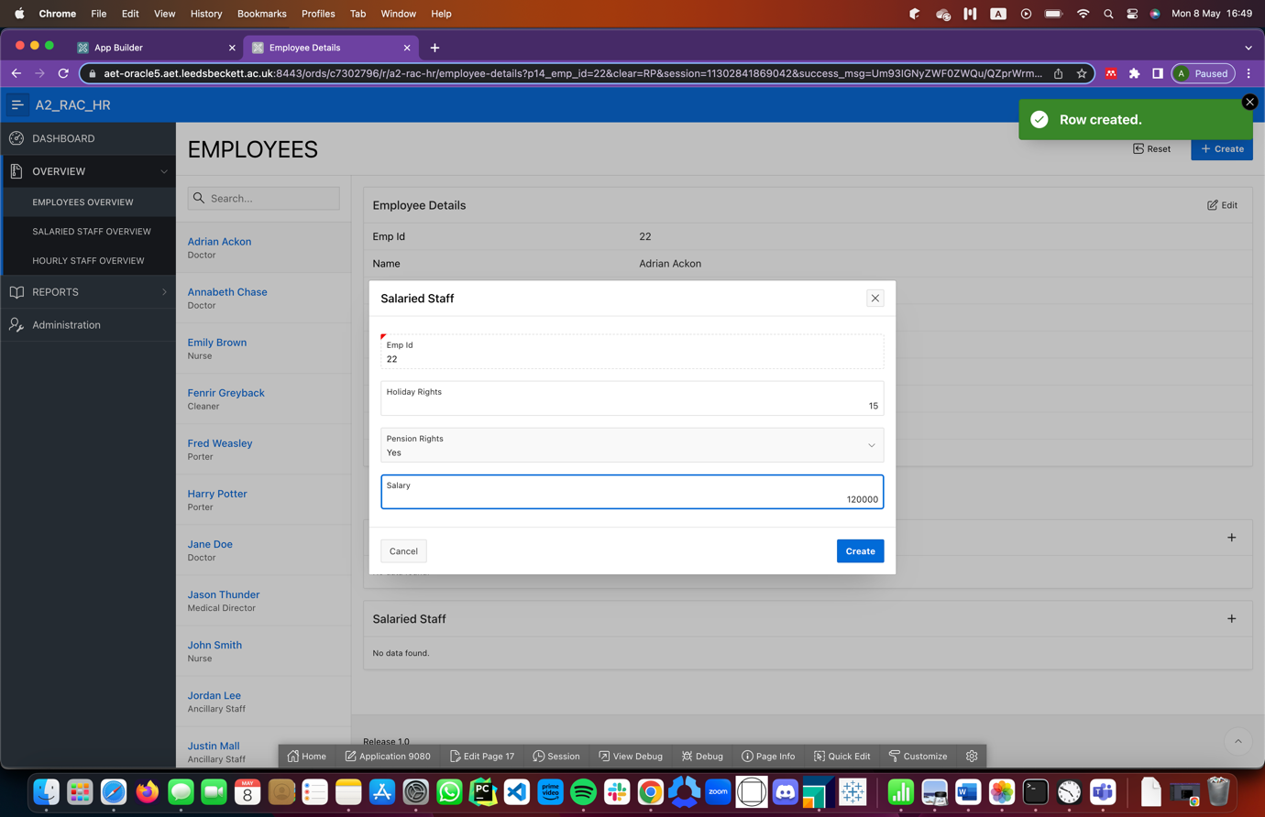

Figure 34: Editing a Salaried Staff record by changing the Salary

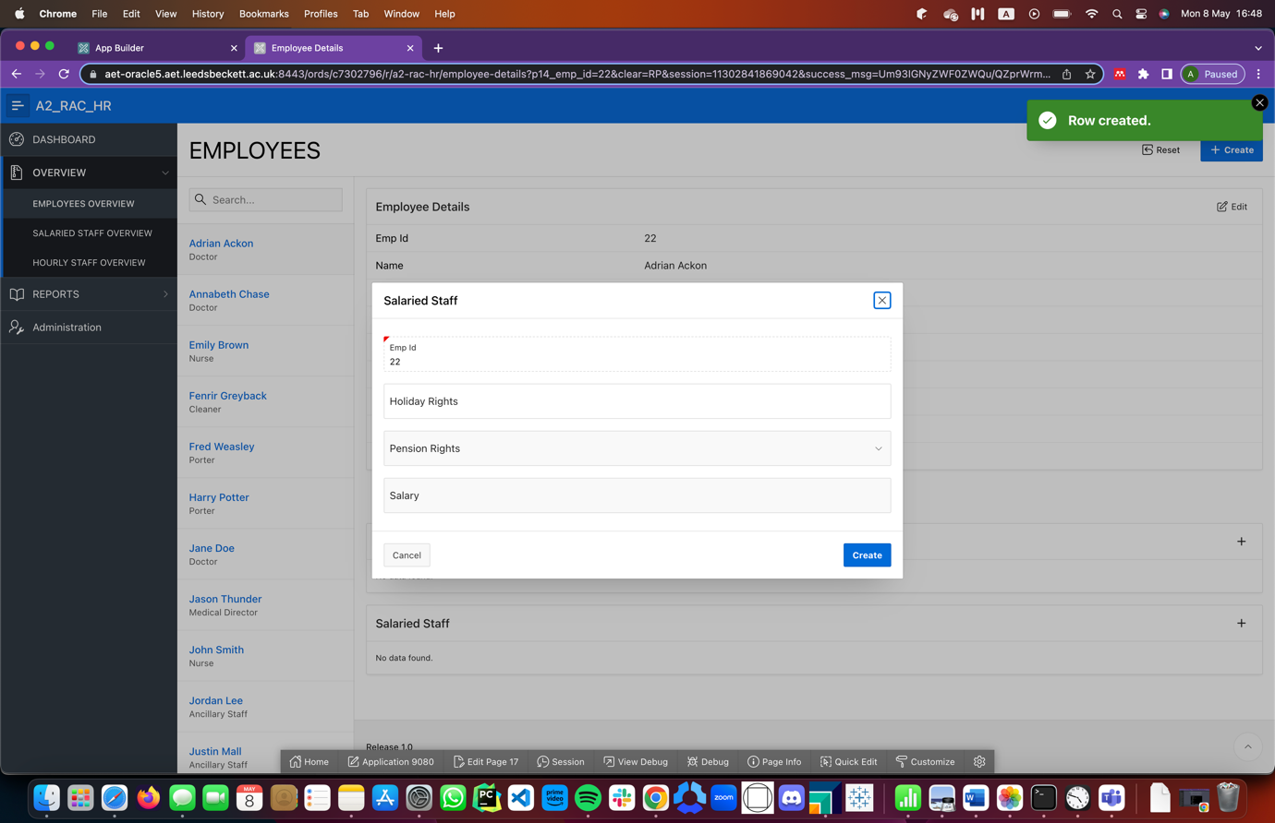

Figure 35: Creating a Salaried Staff record

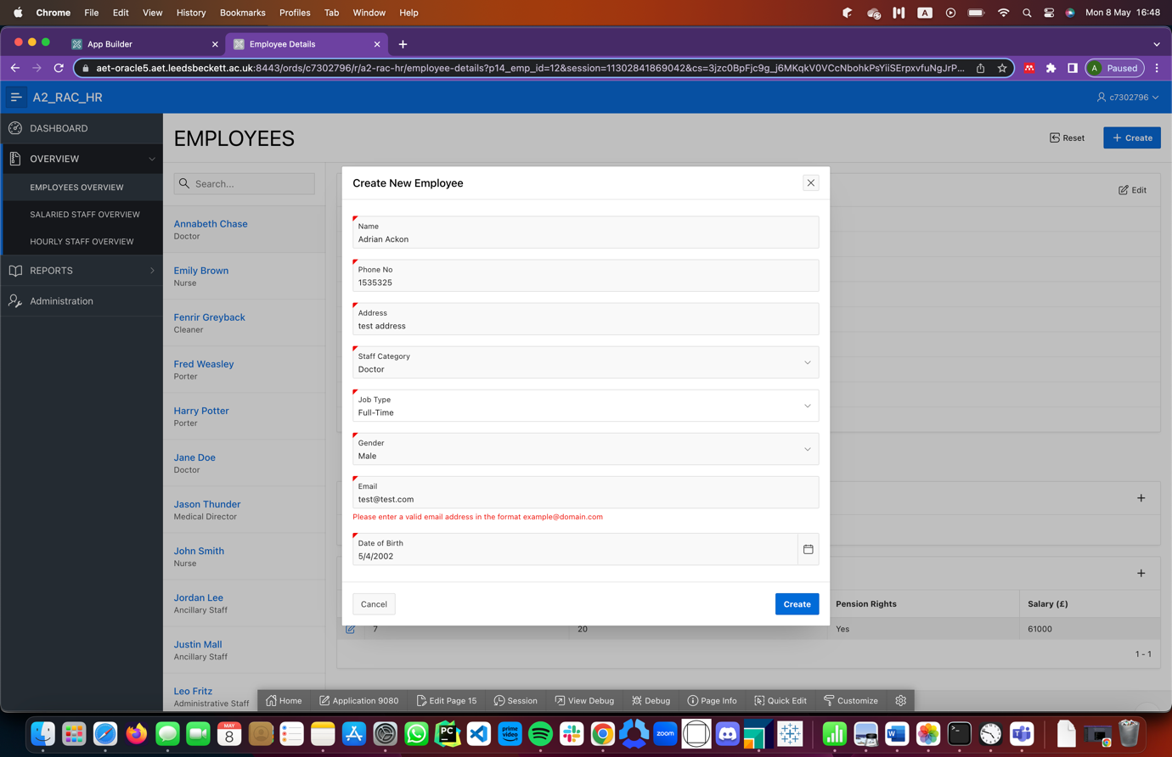

Figure 36: Error message on create attempt of Employee record with wrong email address format

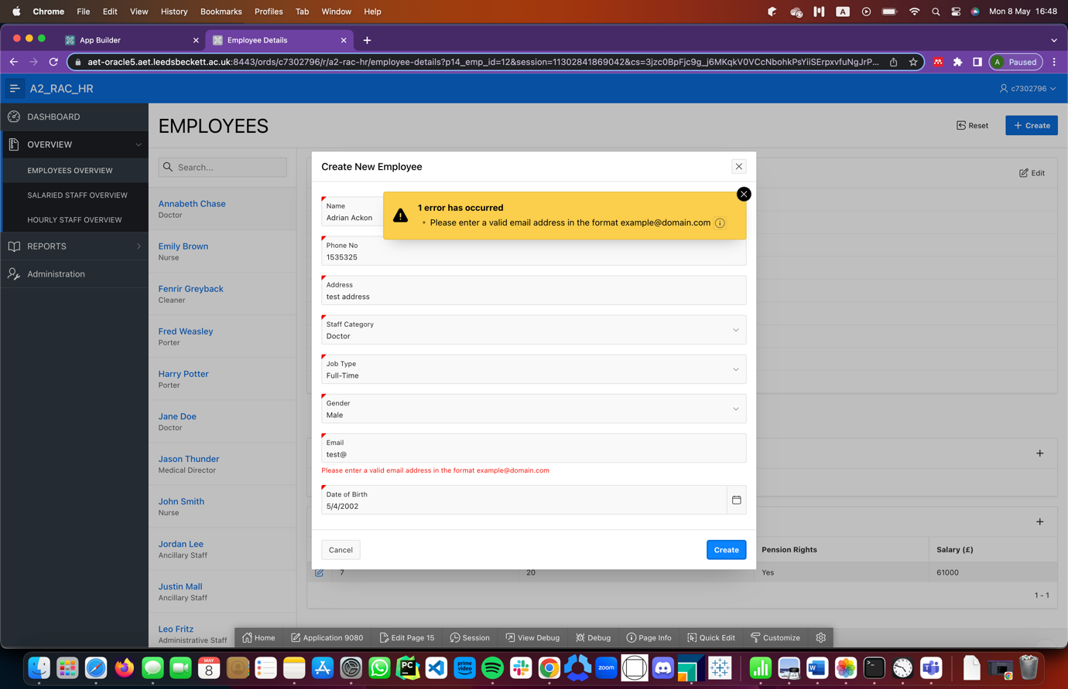

Figure 37: Error message on create record with email formatting error.

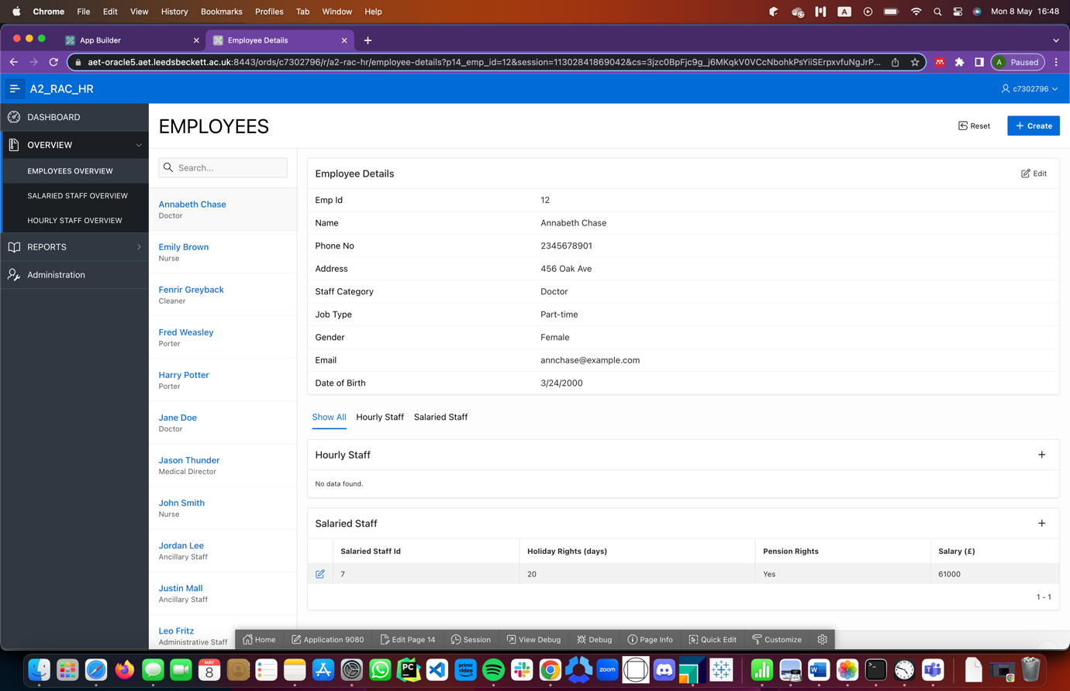

Figure 38: Information that can be viewed in the Employee Master Record form

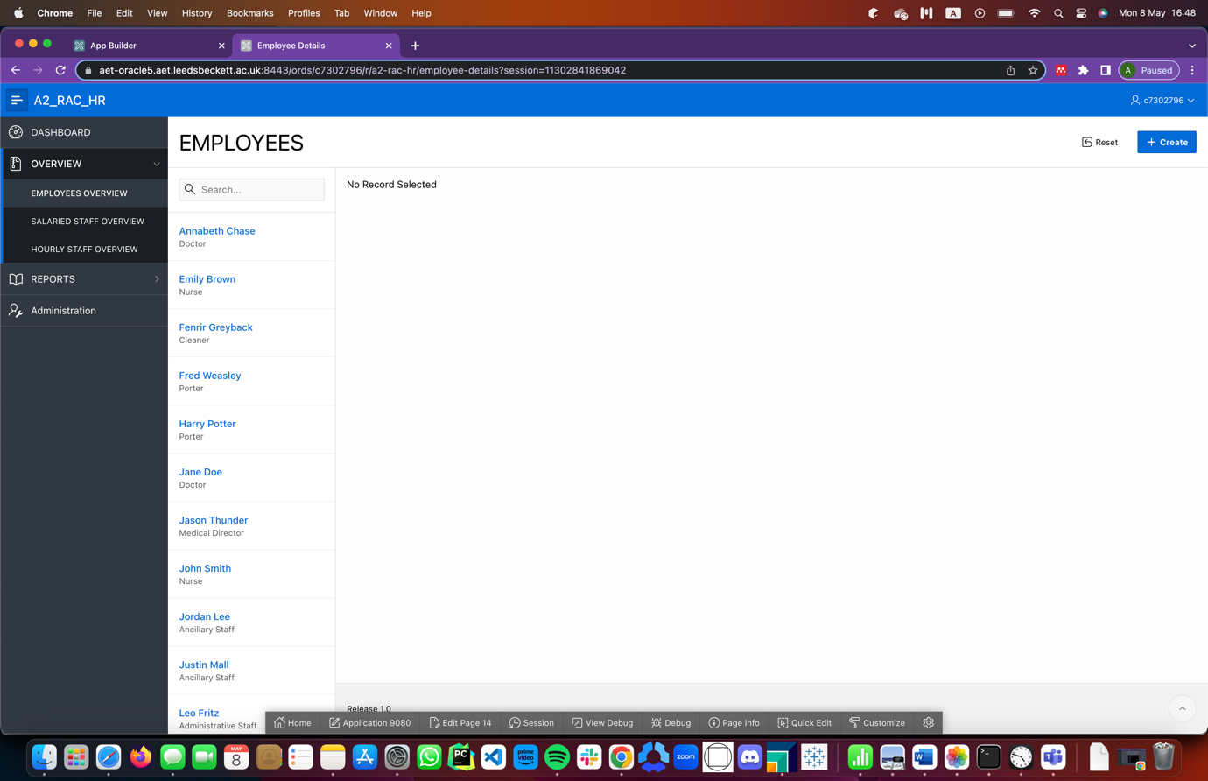

Figure 39: General Layout of the Employee Master table

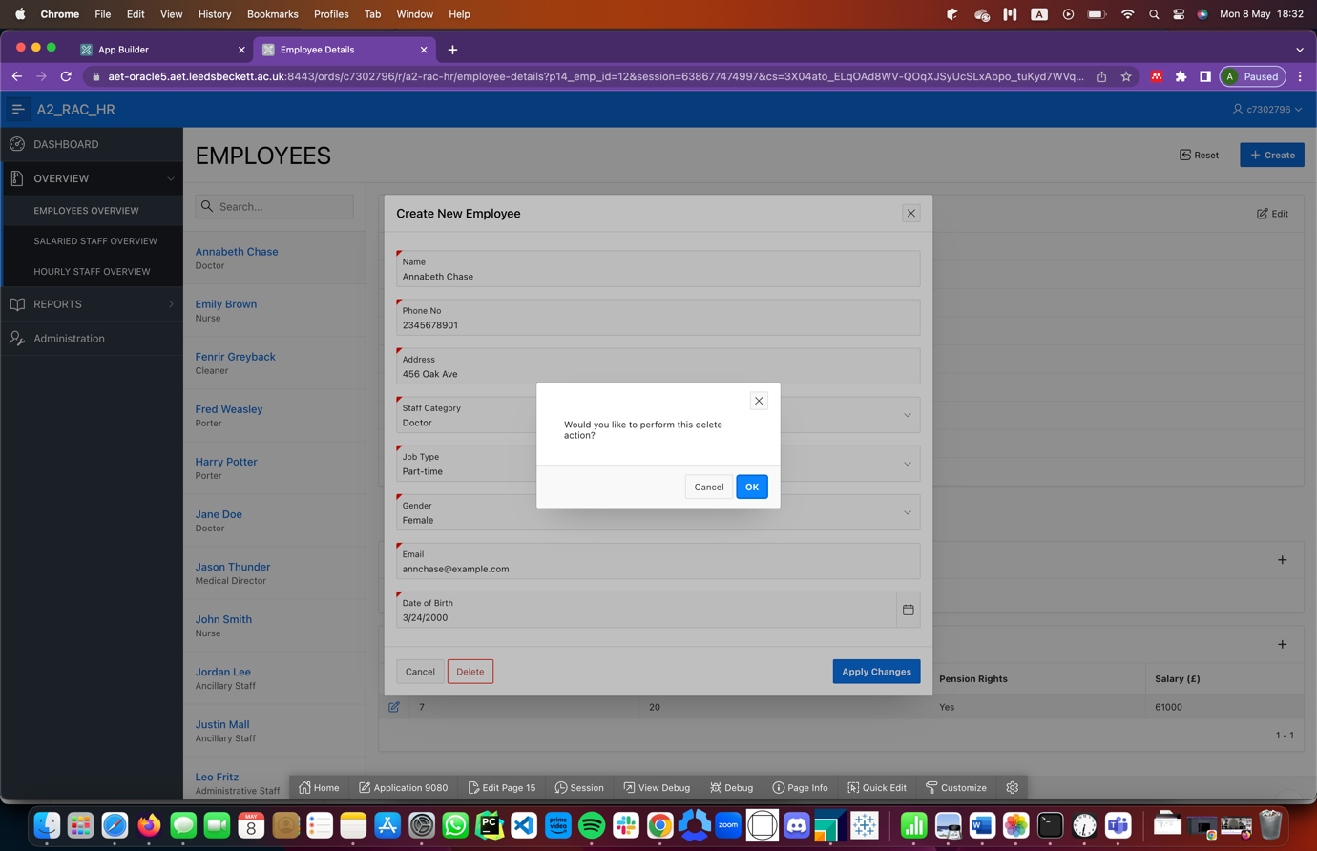

Figure 40: Deleting a record

## Task 2: Apex Reports

Five reports were generated using intermediate and advanced SQLs to produce reports that were displaying important information to Users of the application.

**Employee Grid Report**: This report, an interactive grid, presents a list of employee names, staff category they belong to and the hourly wage or salaries they earn. While viewing this report, the User is able to rearrange the columns as desired, sort and filter on any columns. The query used to produce this uses a left join.  
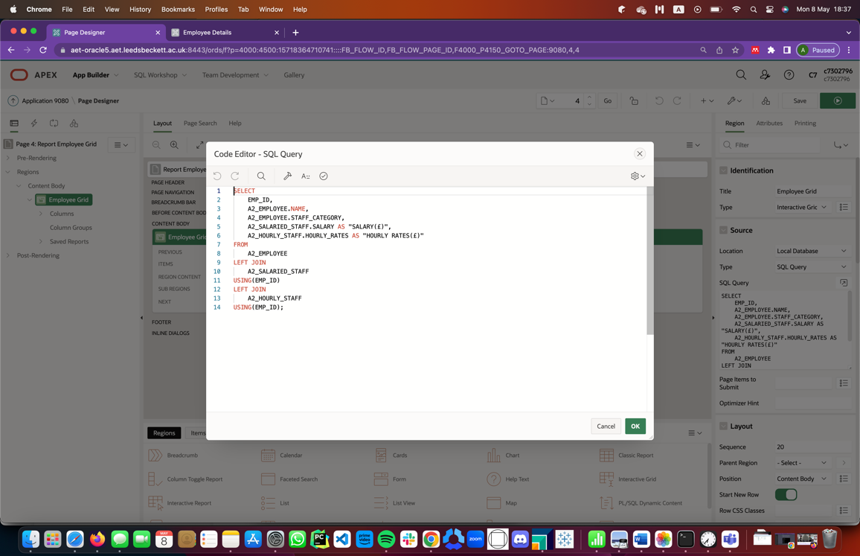

Figure 41: SQL Query for Producing Employee Grid Report

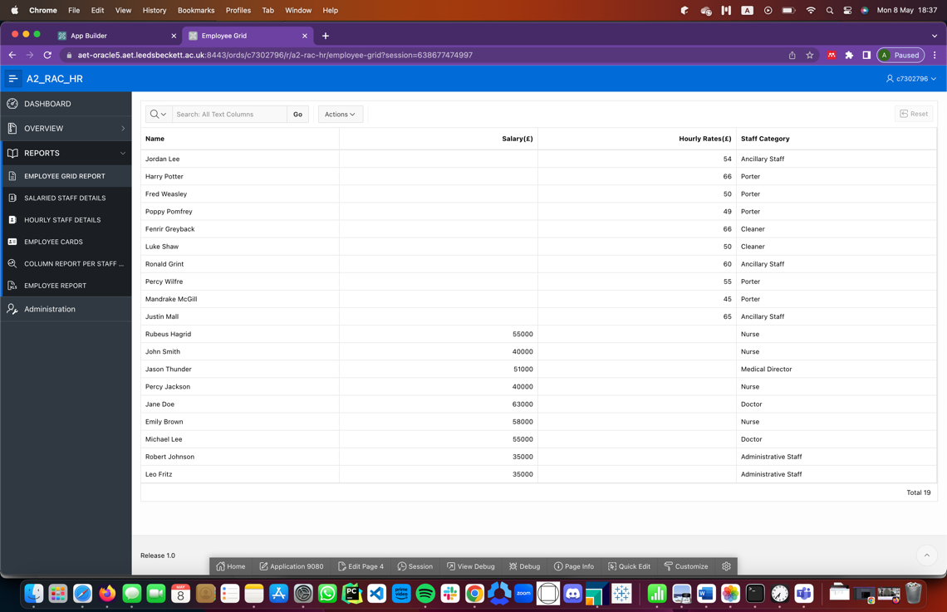

Figure 42: Data as it appears in the Employee Grid Report

**Salaried Staff Details**: This report, also an interactive grid, produces a report that displays the information about salaried staff workers. While viewing this report, the User can rearrange the columns as desired, sort and filter on any columns. The query used to produce this uses a right join between the employee table and the salaried staff table.

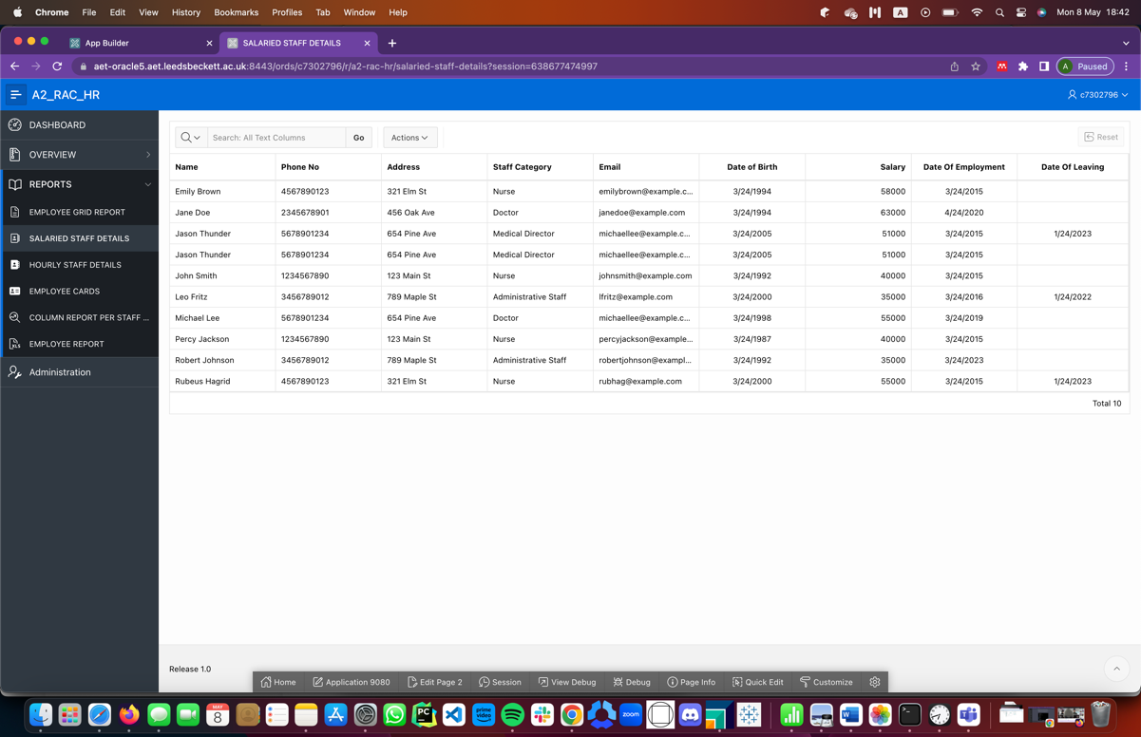

Figure 43: Data as it appears in the Salaried Staff Details Interactive Grid

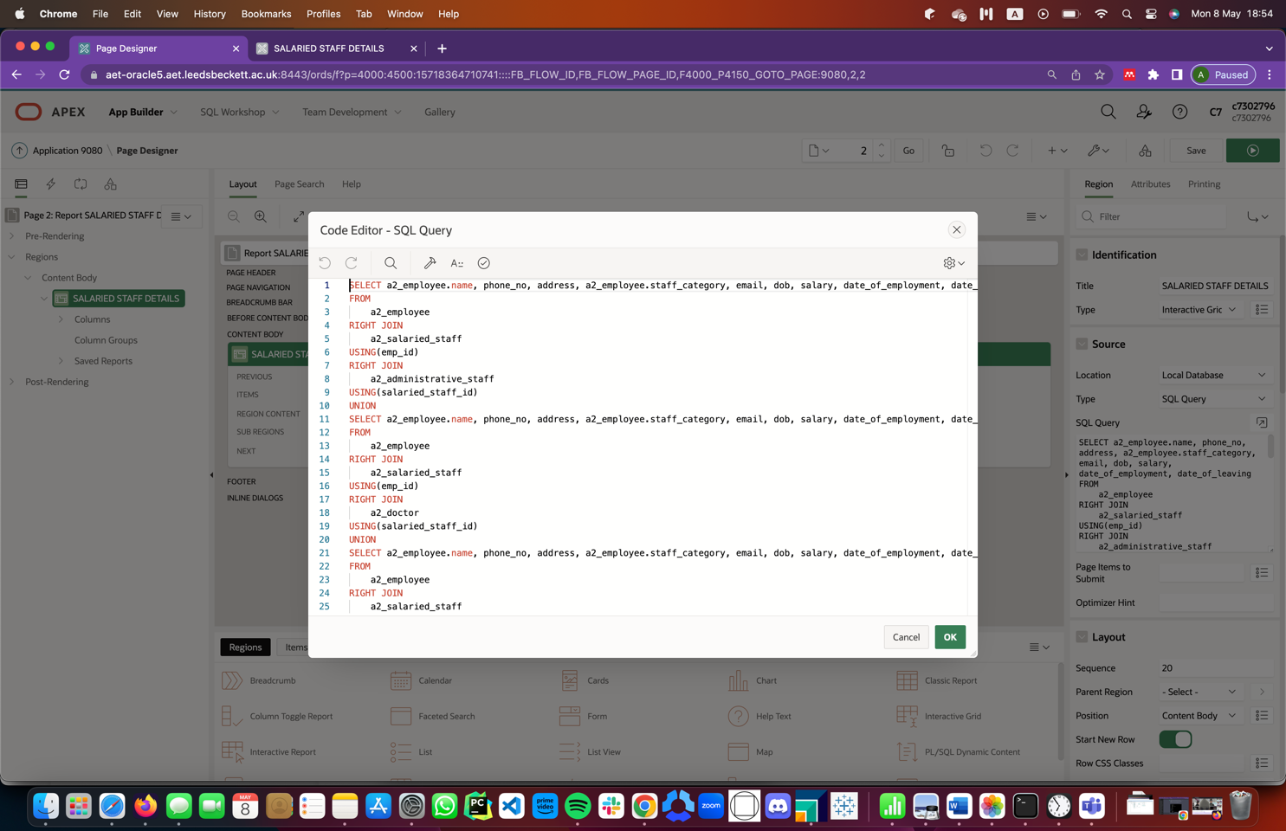

Figure 44: SQL Query used to produce Salaried Staff Details Interactive report

**Hourly Staff Details**: This report, also an interactive grid, displays information about hourly staff workers. While viewing this report, the User can rearrange the columns as desired or sort and filter on any columns.

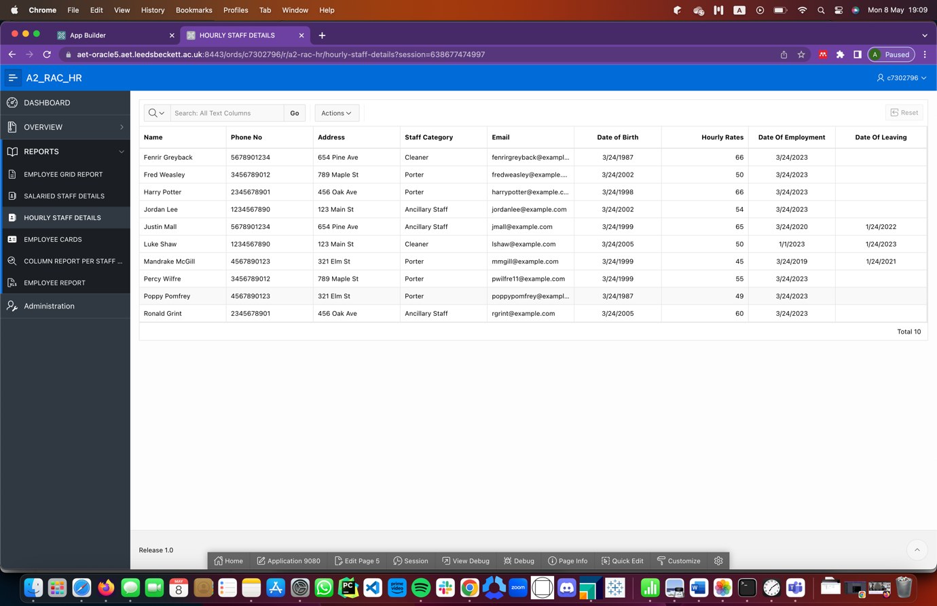

Figure 45: Data as it appears in the Hourly Staff Grid

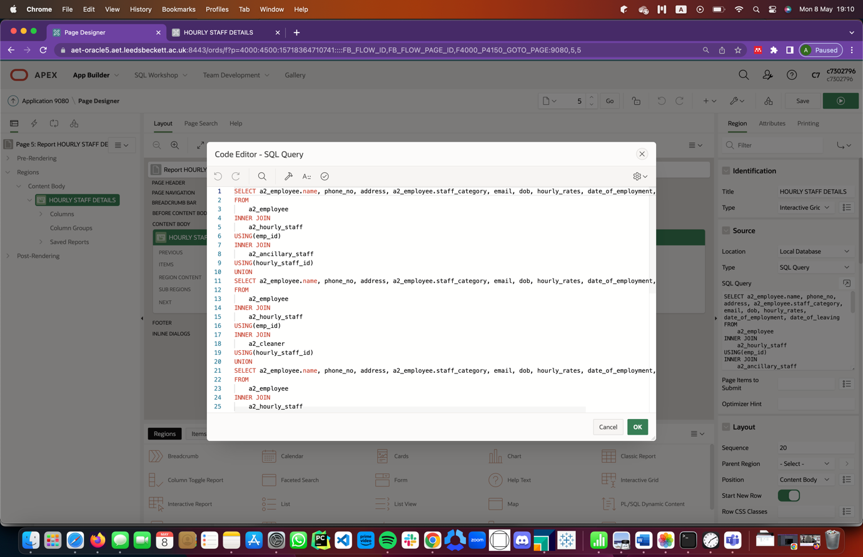

Figure 46: SQL Query used in producing the Hourly Staff Detail Interactive Grid

**Employee Cards**: This report shows the list of employees with their staff category, salary of hourly wage and phone number in a series of card like designs. This is a good report which will help get information about all employees at a glance. The query used to generate this report used an inner join.

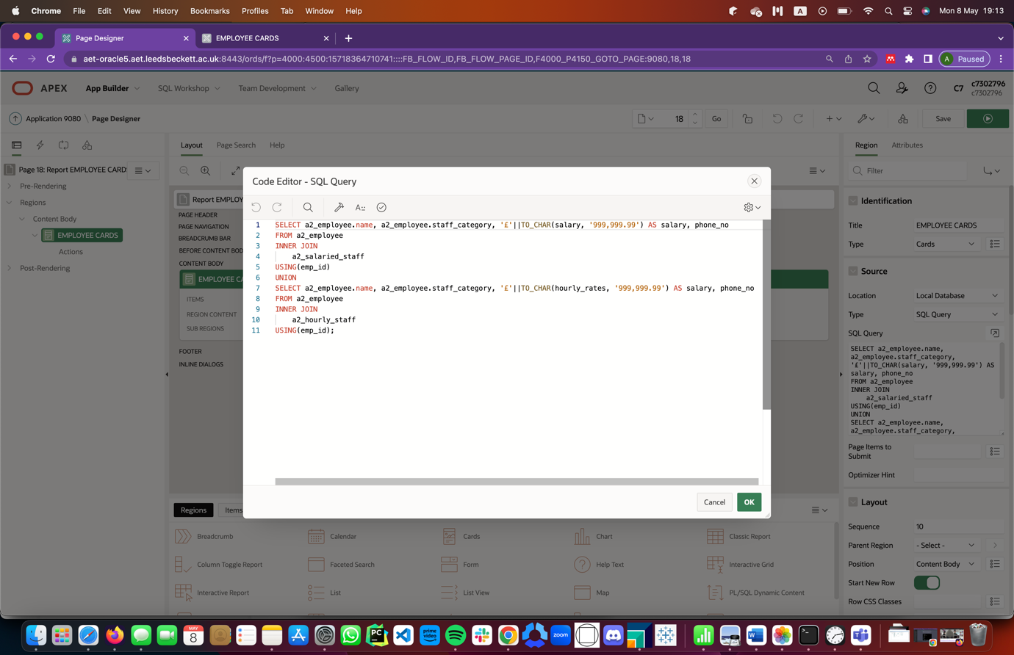

Figure 47: SQL Query to produce Employee Card Reports

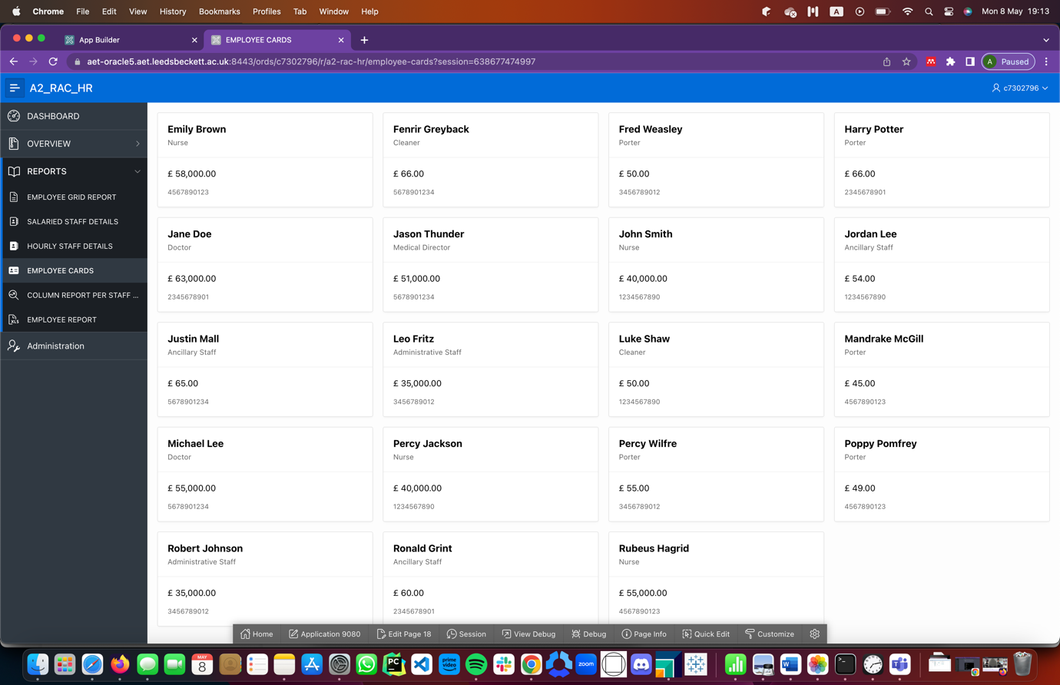

Figure 48: Data as it appears in the Employee Cards Report

**Staff Category Column Report**: This report shows the following information about each and every staff category in the form of columns which can be filtered, rearranged and hidden: Staff category name, whether or not the employees belonging to that staff category receive salaries or hourly wages, the total number of leave days in a period for each employee belonging to a particular category and the average salary or hourly wage earned by employees in that staff category. This report was produced using inner joins.

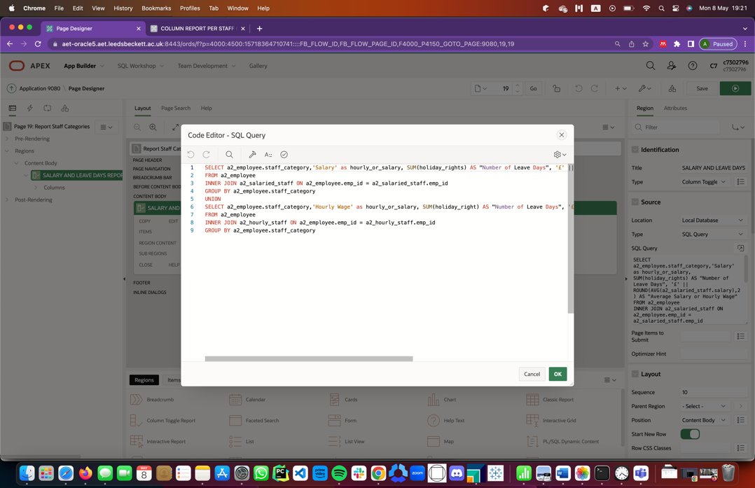

Figure 49: SQL Query used to produce the Staff Category Column Report

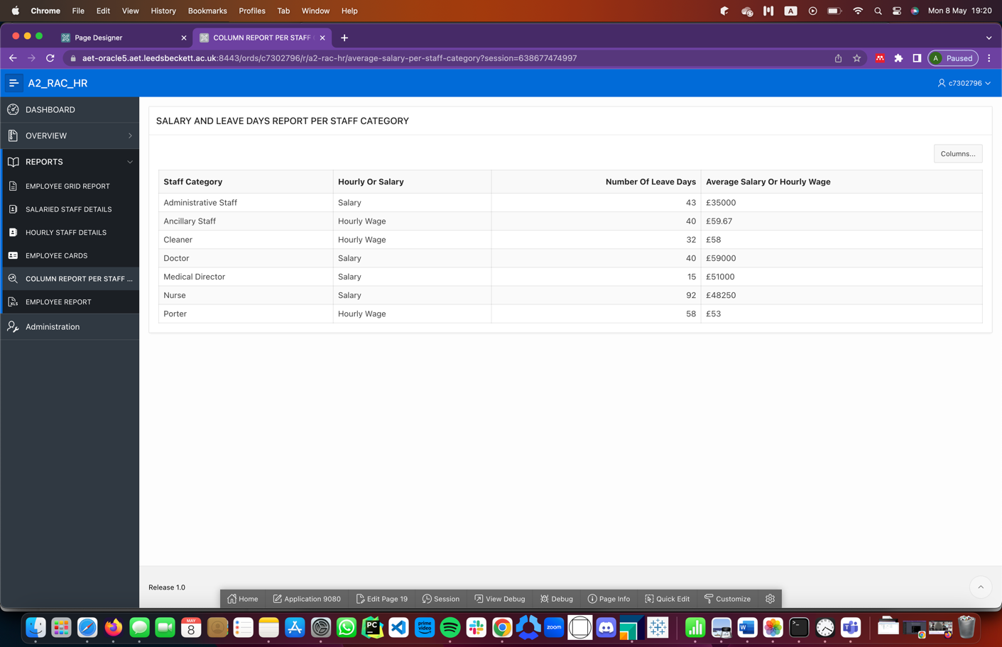

Figure 50: Data as it appears in the Staff Category Report

**Employee Report:** This report, in the form of a static HTML report, displays a full list of employees with the staff category they belong to. The query used to generate this used Union operator.

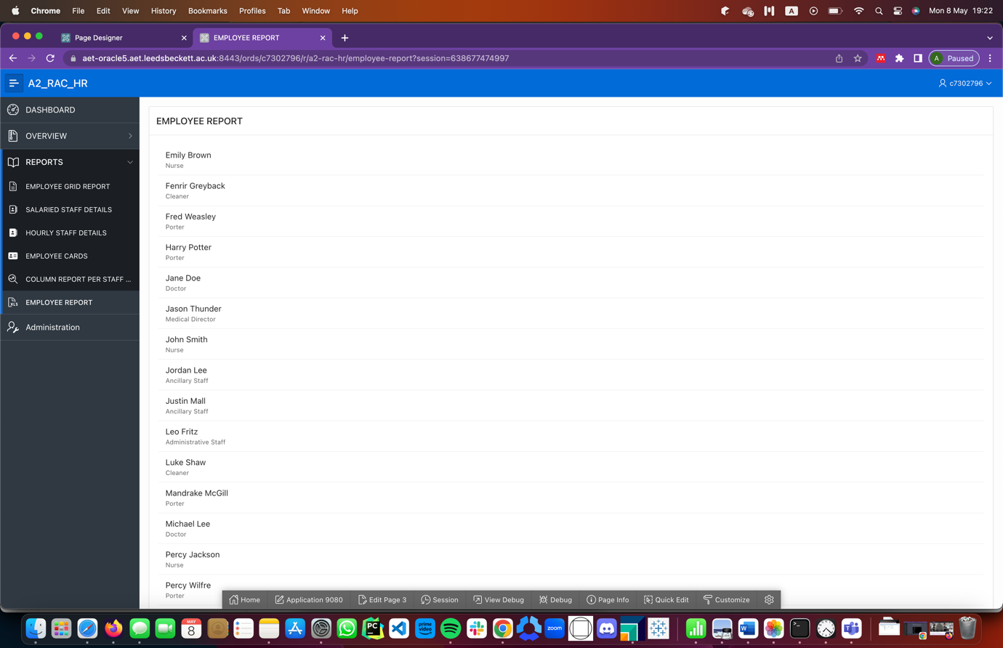

Figure 51: Data as it appears in the Employee Report

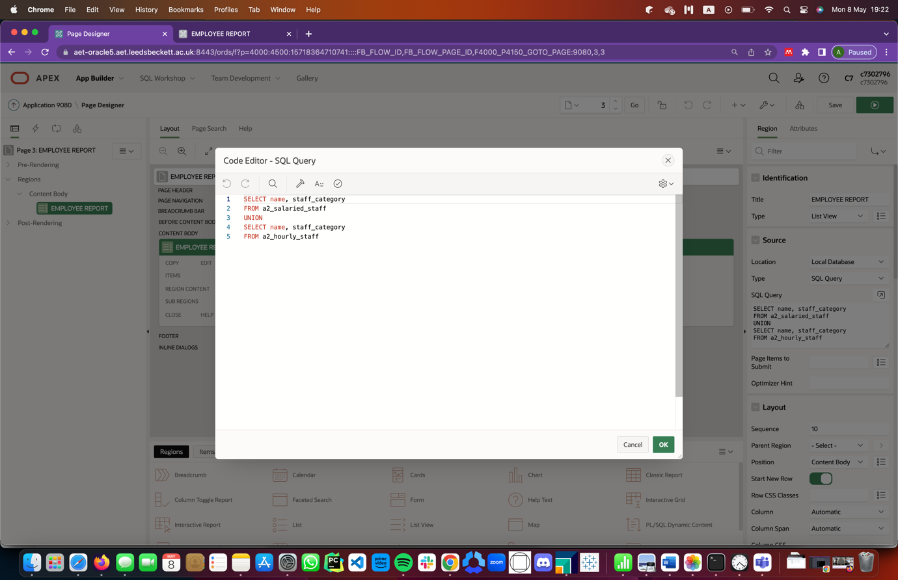

Figure 52: SQL Query used to produce the Employee Report

## Task 3: Dashboard

A dashboard, also acting as the homepage of the application, was designed using five charts which showed visually some analysis of the data that could be found in the application. Dashboards are really important as they consolidate data into a unified location with secure data storage(*Why Are Dashboards So Important for Your Business? 8 Ways They Help Improve Business Performance | Databox Blog*, n.d.). Dashboards can help Users gain insights, monitor performance, and make informed decisions, which can lead to improved productivity and better outcomes.

Five charts were produced in the dashboard as seen in the images below and these are going to be discussed in brief.

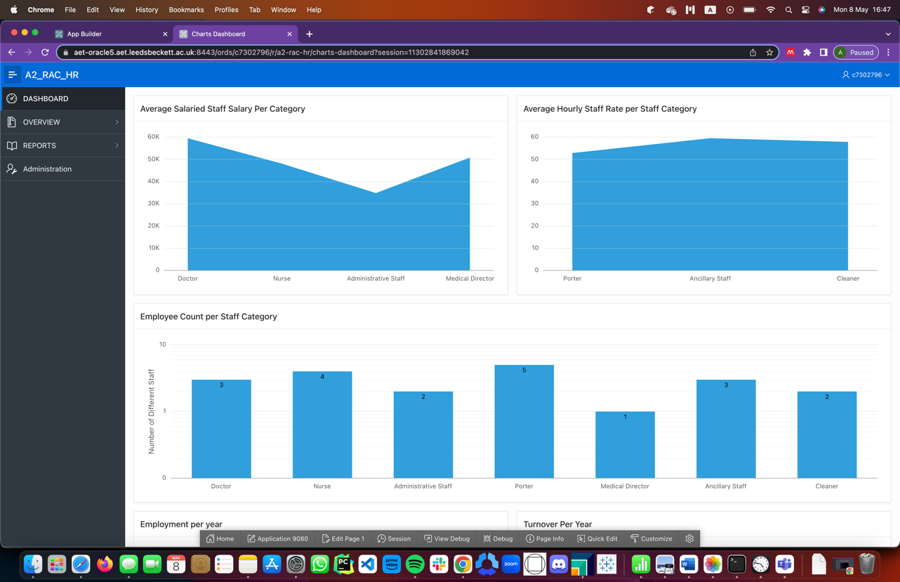

Figure 53: Dashboard as it appears with example data (1)

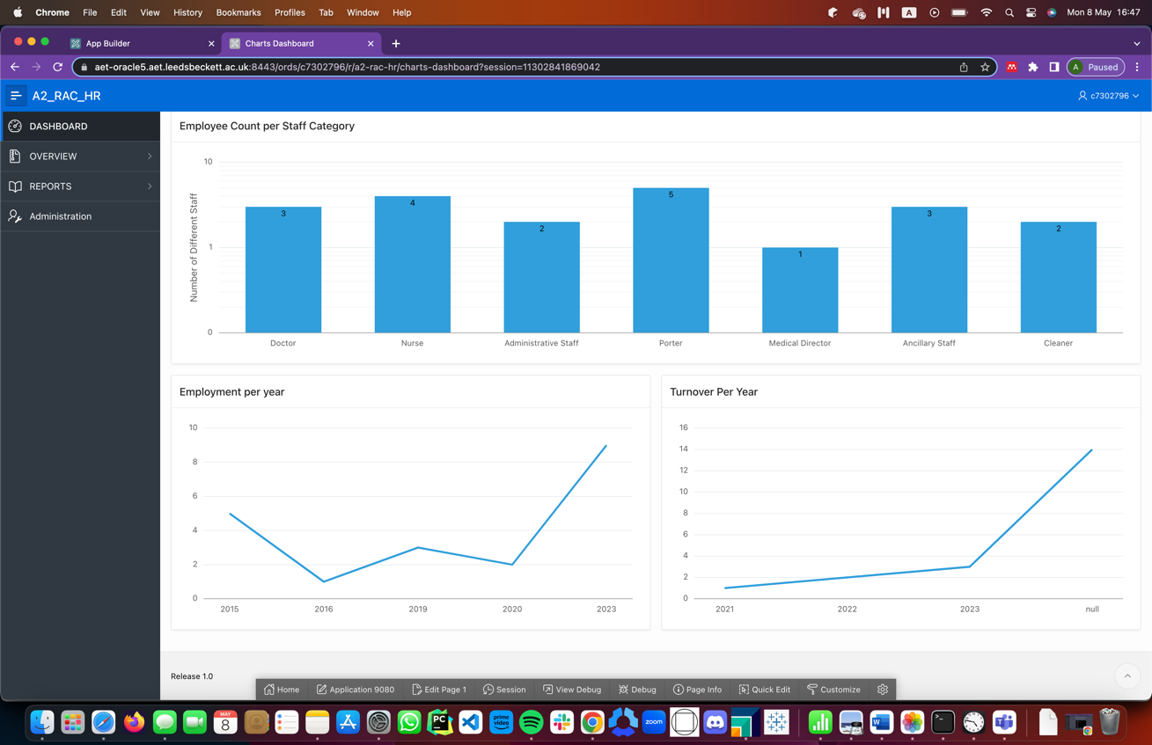

Figure 54: Dashboard as it appears with example data (2)

To generate the first two charts, both bar graphs, in the top left-corner and right-corner of the dashboard, it was considered that it will be important to know the average amount being paid to each employee based on the category of staff they belong to. Knowing this information will be helpful when budgeting, knowing the salary or wage competitiveness level at the company and performance management of employees.

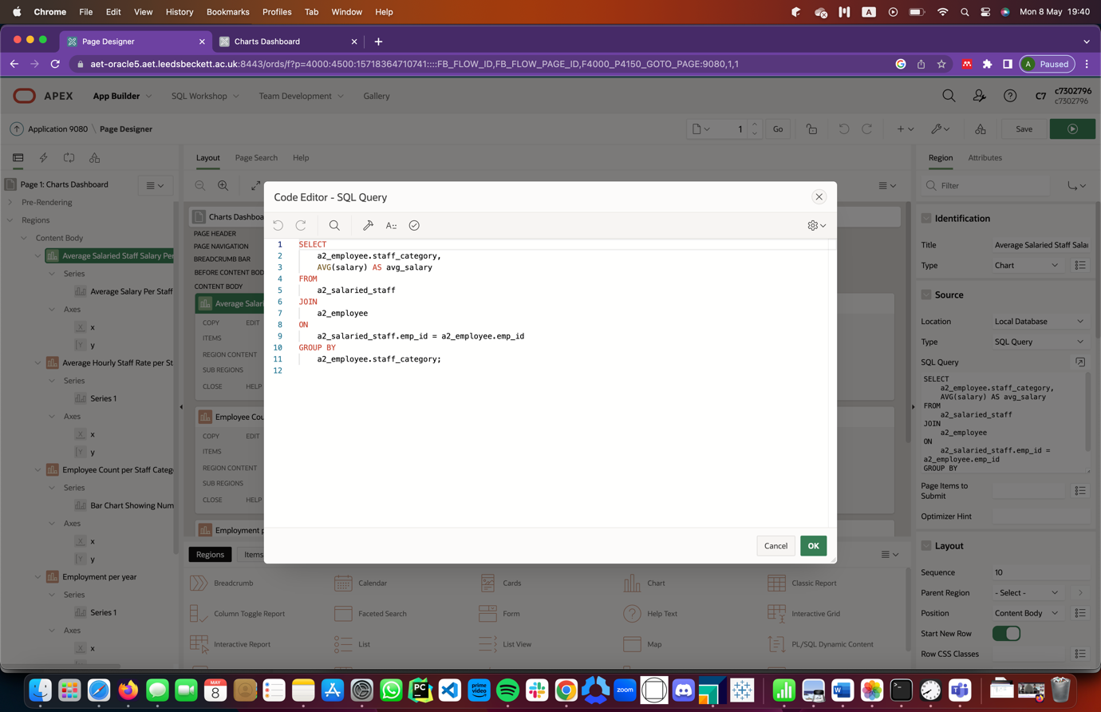

Figure 55: SQL Query to generate chart for Average Salary Per Salaried Staff Category

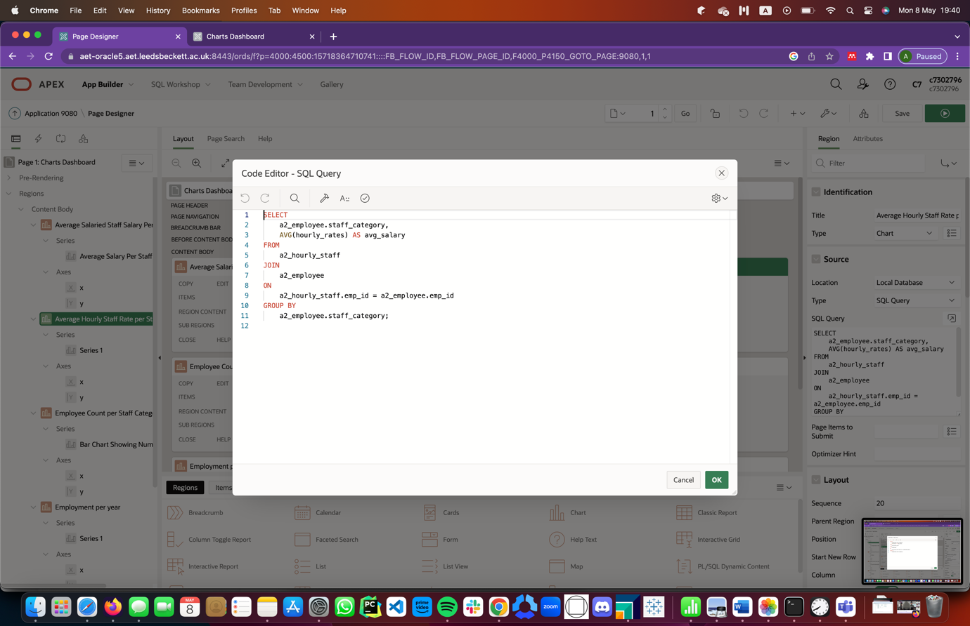

Figure 56: SQL Query to generate chart for Average Hourly Wage per Hourly Staff Categories

The third chart, also a bar graph, which lies in the center of the dashboard, displays the count of employees based on the category of staff they belong to. Knowing this information can influence workforce planning and management, provide insights into an organizations structure and monitor workforce diversity.

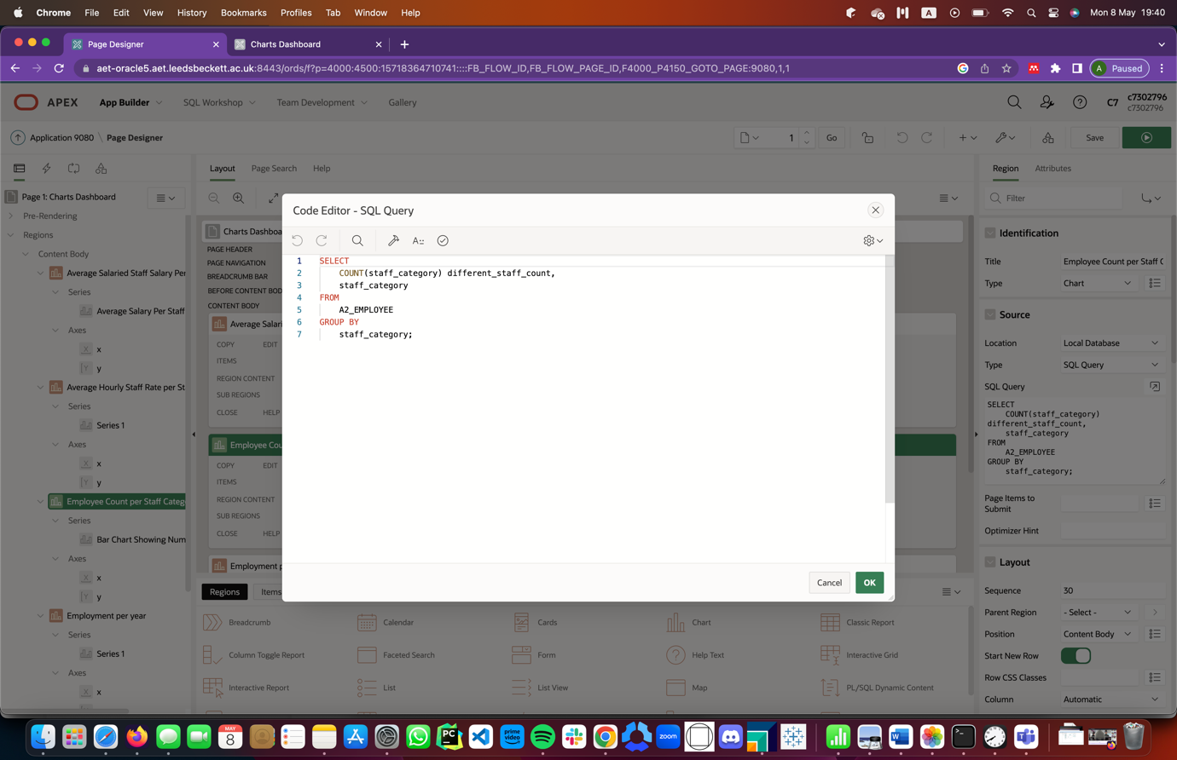

Figure 57: SQL Query to generate chart to calculate the total number of employees in each staff category

The fourth chart, which can be seen at the bottom-right corner of the dashboard, depicts a line graph which shows the trend of number of people employed each year over a particular period, in this case from the year 2000 till date. Knowing this information makes the company aware of the organization’s growth and workforce trend. The information can be used together with information from other reports when budgeting.

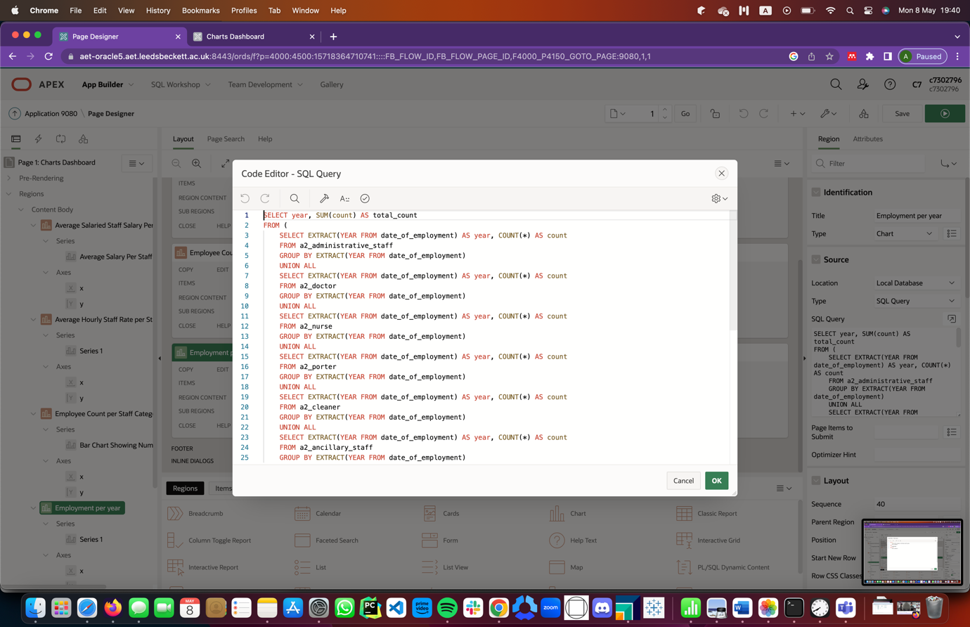

Figure 58: SQL Query to generate chart for tracking employment count over the period.

The fifth and final chart, which can be located in the bottom right corner of the application, depicts the number of employees who turnover each year within a particular period, in this particular context, from the year 2000, based on the data available. Knowing this information and using it together with other reports can also help know workforce trends, to be able to measure employee retention rate, evaluate the effectiveness of HR policies, since this application is being used specifically by the HR team, to assess the cost of turnover and to identify trends and patterns.

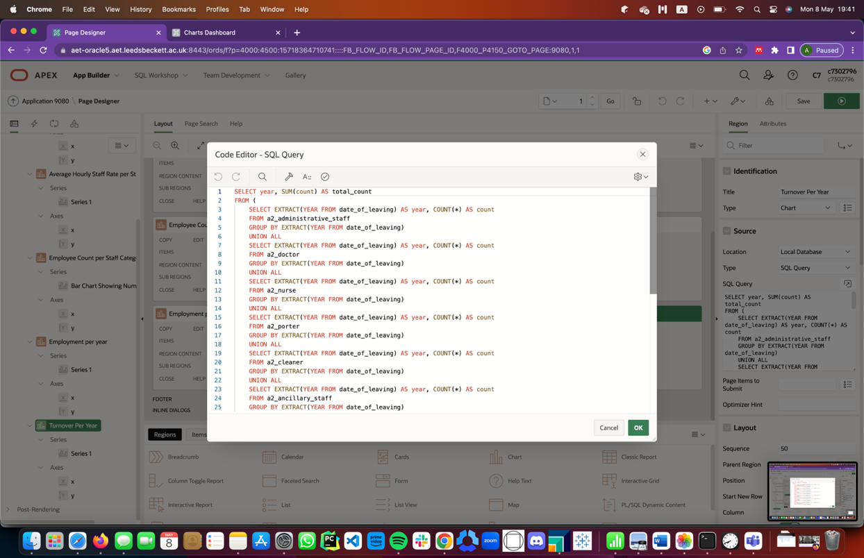

Figure 59: SQL Query to generate chart for tracking turnover over the period.

It should be noted that in as much as there is a need to visualize information, any information of any employee who has resigned needs to be anonymized or deleted after a particular period of time(*General Data Protection Regulation (GDPR) – Official Legal Text*, n.d.).

Also, roles should be allocated well since assigning someone the wrong role will give them access to data which they might not need to have access to or vice versa.

This application has been carefully designed and implemented to assist the HR team in the execution of their duties by providing more insights into employee data.

## Part 2: Report

In the age of data-driven decision-making, organizations are increasingly reliant on the efficient storage, management, and retrieval of vast amounts of information. The underlying technology responsible for facilitating these processes, namely database management systems (DBMS), has evolved significantly over the years to adapt to the changing needs of modern enterprises. This report aims to critically evaluate the theoretical foundations of current relational database management systems by comparing and contrasting Structured Query Language (SQL) and Not only Structured Query Language (NoSQL) approaches. It will also explore emerging database concepts that support data analytics, as well as assess their potential usefulness to our case study organization. Finally, this paper will discuss concerns about how these emerging technologies may influence the organization's database technology solutions in the future. By examining the merits and limitations of these various approaches, this report will provide a comprehensive understanding of the ever-evolving landscape of database management systems.

Relational database management systems (RDBMS) are based on the principles of the relational model, proposed by Edgar F. Codd in 1970(Codd, 1983). RDBMSs use a structured query language (SQL) to manipulate and retrieve data stored in tables with predefined schemas. On the other hand, NoSQL databases offer a non-relational approach to data storage and retrieval, using document-oriented, key-value, graph, or column-oriented models, among others(Molina et al., 2016).

The concept of non-relational databases, also known as NoSQL databases, emerged in the early 2000s as a response to the limitations of traditional relational databases in handling large volumes of unstructured or semi-structured data. There is no one individual who can be credited with introducing the concept of NoSQL databases, as it was more of a collective effort by developers and companies seeking alternatives to traditional relational databases. However, some of the earliest NoSQL databases were developed by companies such as Google, Amazon, and Facebook, who needed to store and process vast amounts of data in real-time, often across distributed systems(*What Is NoSQL? NoSQL Databases Explained | MongoDB*, n.d.).

SQL-based RDBMSs have been the dominant database technology for decades due to their ability to provide a reliable and scalable solution for managing large amounts of structured data. They offer several benefits such as data consistency, transactional integrity, and efficient data retrieval using SQL queries. However, RDBMSs have limitations in handling unstructured data, such as text, images, and videos, and may struggle to scale horizontally(Bartholomew, n.d.). In the context of Rest-assured Care Foundation, an RDBMS can be used to store patient data, treatment records, staffing information, appointments, wards and beds, among other things. Tables could be created to store data for each of the data points mentioned earlier in columns. These tables could then be related to each other via several relationships that could be identified, eventually forming a large structured and organized way to manage and analyze the important data points mentioned earlier.

An example of such an implementation is that which is discussed in Part 1 of this paper, where staffing information has been stored using Oracle’s Application Builder, which is built on top of Oracle’s RDBMS(Monger et al., 2009).

NoSQL databases, on the other hand, are designed to handle unstructured data and offer horizontal scalability, making them suitable for big data and distributed systems. NoSQL databases can also provide better performance and availability than traditional RDBMSs, as they do not enforce a schema and allow for flexible data modeling. However, NoSQL databases may not provide the same level of transactional consistency and may require additional effort in data management due to the lack of a standard query language(Bartholomew, n.d.)**.**

There are several emerging database concepts that can be useful for Rest-Assured Care Foundation. These include but are not limited to: Document-oriented NoSQL databases; Key-value NoSQL databases; Columnar NoSQL databases; Graph NoSQL databases.

Document-oriented NoSQL databases are designed to store and manage unstructured and semi-structured data, such as JavaScript Object Notation (JSON), Extensible Markup Language (XML), and binary data(Chevalier et al., 2015). In the context of Rest-assured Care Foundation, a document-oriented NoSQL database can be used to store patient data, treatment records, staff information and waiting lists in a more flexible format than a traditional relational database. Each record in each data point case can be stored as a separate JSON document which will contain different data types and structures with identifiers as keys. In addition to this document, sub-documents could also be created to store additional information(Vera et al., n.d.).

Key-value NoSQL databases are designed to store and manage data as a collection of key-value pairs(*A Guide to Key-Value Databases | InfluxData*, n.d.). In the context of Rest-assured Care Foundation, a key-value NoSQL database can be used to store and manage treatment records for patients, waiting lists, staff schedules, financial data as well as other types of data that can be effectively represented as key-value pairs. In each data point case, an identifier is used as a key to map onto corresponding values which are stored in either JSON documents or binary objects, depending on the type of data being stored. This can allow for fast and efficient retrieval of data by querying the database using the key identifiers(González-Aparicio et al., 2018; *Key-Value Databases, Explained - KDnuggets*, n.d.).

Columnar NoSQL databases are designed to store and manage data in columns rather than rows, making them well-suited for analytical queries and reporting(*NoSQL Database Types Explained: Column-Oriented Databases | TechTarget*, n.d.). In the context of Rest-assured Care Foundation, a columnar NoSQL database can be used to store and manage patient treatment data, staff performance data, financial data and patient demographics data among many others. Each record for the data points mentioned earlier will be stored in separate columns with each column representing a specific attribute(*NoSQL Database Types Explained: Column-Oriented Databases | TechTarget*, n.d.). This will result in fast and efficient retrieval of data, making it easier for managing and analyzing information.

Graph NoSQL databases are designed to store and manage data in a network of nodes and edges, making them well-suited for managing and analyzing complex relationships between different data points(*What Is a NoSQL Graph Database? | Ontotext Fundamentals*, n.d.). In the context of Rest-assured Care Foundation, a graph NoSQL database can be used to manage patient treatment data, staffing data, patient demographics data, waiting lists and other types of data that involve complex relationships. Each data item can be identified as a separate node in the graph, with each node linked together by edges which signify the relationships between them. Each node contains attribute. By using a graph NoSQL database, Rest-assured Care Center will be able to store and manage data in a highly flexible and efficient way, allowing for easy traversal and analysis of complex relationships between different data points if GraphSQL is used(Khan & Shahzad, 2017).

It is becoming increasingly common for companies to use both types of databases in their data management strategies as it is possible to use both non-relational and RDBMS to analyze the same information for the same company(Dave, 2016; *How to Choose between SQL and NoSQL Databases - Simple Talk*, n.d.; *SQL vs. NoSQL: The Differences Explained + When to Use Each | Coursera*, n.d.). Different database technologies may have different strengths and weaknesses when it comes to data analysis. For example, a graph database may be better suited for analyzing complex relationships between different data points, while a columnar database may be better suited for performing analytical queries on large volumes of data(Jatana et al., n.d.; Ordonez et al., 2010). By using both non-relational and relational database technologies, Rest-Assured Care Center can take advantage of the strengths of each approach to effectively manage and analyze their data. This can help to improve decision-making, provide better patient care, and increase operational efficiency(Codd, 2011; Moniruzzaman & Hossain, 2013).

It will therefore not be a surprise in the near future for this case study that both implementations will be used in Rest-Assured Care Foundation and different analysis be performed on them to get different insights which will be useful to the organization. But, it is important to note that there are some pressing concerns that might arise in trying to implement this data model.

Firstly, integrating data between relational and non-relational databases can be a complex and time-consuming process. It is important to ensure that the data is synchronized and consistent across both databases to avoid potential issues with data inconsistencies or data duplication(Maowa, 2017).

Another important thing to take note of is if both relational and non-relational databases are being used, it is important to ensure that queries are optimized for each database type. This may require different query languages or query optimization techniques for each database, which can be complex and time-consuming(Maowa, 2017).

Another thing to consider is that, using both relational and non-relational databases may create additional challenges in terms of data governance and data management. It is important to ensure that data is governed consistently across both database types to avoid potential issues with data privacy, data security, or compliance(*General Data Protection Regulation (GDPR) – Official Legal Text*, n.d.; Maowa, 2017).

Lastly, using both relational and non-relational databases may create additional challenges in terms of scalability. It is important to ensure that both database types are able to scale effectively to handle increasing volumes of data and user traffic.

Overall, the implications of the theoretical foundations of current relational database management systems are far-reaching, and the database technology landscape is constantly evolving. Organizations, including Rest-Assured Care Center, must continue to critically evaluate their database technology solutions and be open to adopting emerging other database concepts to support their evolving data processing and analysis requirements.

## 4. Bibliography

*A Guide to Key-Value Databases | InfluxData*. (n.d.). Retrieved May 4, 2023, from https://www.influxdata.com/key-value-database/

Bartholomew, D. (n.d.). *SQL vs. NoSQL*. Retrieved May 2, 2023, from https://dl.acm.org/doi/fullHtml/10.5555/1883478.1883482

Chevalier, M., El Malki, M., Kopliku, A., Teste, O., & Tournier, R. (2015). Implementation of multidimensional databases with document-oriented NoSQL. *Lecture Notes in Computer Science (Including Subseries Lecture Notes in Artificial Intelligence and Lecture Notes in Bioinformatics)*, *9263*, 379–390. https://doi.org/10.1007/978-3-319-22729-0_29/COVER

Codd, E. F. (1983). A relational model of data for large shared data banks. *Communications of the ACM*, *26*(1), 64–69. https://doi.org/10.1145/357980.358007

Codd, E. F. (2011). Relational database: a practical foundation for productivity. *ACM Turing Award Lectures*, 1981. https://doi.org/10.1145/1283920.1283937

Dave, M. (2016). *SQL and NoSQL Databases*. https://www.researchgate.net/publication/303856633

*General Data Protection Regulation (GDPR) – Official Legal Text*. (n.d.). Retrieved May 5, 2023, from https://gdpr-info.eu/

González-Aparicio, M. T., Younas, M., Tuya, J., & Casado, R. (2018). Testing of transactional services in NoSQL key-value databases. *Future Generation Computer Systems*, *80*, 384–399. https://doi.org/10.1016/J.FUTURE.2017.07.004

*How to choose between SQL and NoSQL databases - Simple Talk*. (n.d.). Retrieved May 4, 2023, from https://www.red-gate.com/simple-talk/databases/nosql/how-to-choose-between-sql-and-nosql-databases/

Jatana, N., Puri, S., Ahuja, M., Kathuria, I., & Gosain, D. (n.d.). *A Survey and Comparison of Relational and Non-Relational Database*. Retrieved May 4, 2023, from www.ijert.org

*Key-Value Databases, Explained - KDnuggets*. (n.d.). Retrieved May 4, 2023, from https://www.kdnuggets.com/2021/04/nosql-explained-understanding-key-value-databases.html

Khan, W., & Shahzad, W. (2017). Predictive Performance Comparison Analysis of Relational & NoSQL Graph Databases. *IJACSA) International Journal of Advanced Computer Science and Applications*, *8*(5). http://hortonworks.com/blog/7-key-drivers-for-the-big-data-market/

Maowa, J. (2017). *A Comparative Study on Big Data Handling Using Relational and Non-Relational Data Model*. https://papers.ssrn.com/abstract=3672094

Molina, J. G., Strauch, C., & Kriha, W. (2016). *A repository for scalable model management NoSQL Databases Lecture Selected Topics on Software-Technology Ultra-Large Scale Sites*. https://doi.org/10.1007/s10270-013-0326-8

Monger, A., Baron, S., & Lu, J. (2009). *More on Oracle APEX for teaching and learning* (pp. 3–12). https://pure.solent.ac.uk/en/publications/more-on-oracle-apex-for-teaching-and-learning

Moniruzzaman, A. B. M., & Hossain, S. A. (2013). NoSQL Database: New Era of Databases for Big data Analytics - Classification, Characteristics and Comparison. *International Journal of Database Theory and Application*, *6*(4). https://arxiv.org/abs/1307.0191v1

*NoSQL database types explained: Column-oriented databases | TechTarget*. (n.d.). Retrieved May 4, 2023, from https://www.techtarget.com/searchdatamanagement/tip/NoSQL-database-types-explained-Column-oriented-databases

Ordonez, C., Song, I. Y., & Garcia-Alvarado, C. (2010). Relational versus non-relational database systems for data warehousing. *International Conference on Information and Knowledge Management, Proceedings*, 67–68. https://doi.org/10.1145/1871940.1871955

*SQL vs. NoSQL: The Differences Explained + When to Use Each | Coursera*. (n.d.). Retrieved May 4, 2023, from https://www.coursera.org/articles/nosql-vs-sql

Vera, H., Boaventura, W., Holanda, M., Guimarães, V., & Hondo, F. (n.d.). *Data Modeling for NoSQL Document-Oriented Databases*.

*What is a NoSQL Graph Database? | Ontotext Fundamentals*. (n.d.). Retrieved May 4, 2023, from https://www.ontotext.com/knowledgehub/fundamentals/nosql-graph-database/

*What Is NoSQL? NoSQL Databases Explained | MongoDB*. (n.d.). Retrieved May 2, 2023, from https://www.mongodb.com/nosql-explained

*Why Are Dashboards So Important for Your Business? 8 Ways They Help Improve Business Performance | Databox Blog*. (n.d.). Retrieved May 8, 2023, from https://databox.com/why-are-dashboards-important

## 5. Appendixes

Find below, the DDL code used for this paper:

--------------------------------------------------------------

-- DATABASE DDL SCRIPT

--------------------------------------------------------------

DROP TABLE A2_MEDICAL_DIRECTOR CASCADE CONSTRAINTS;

DROP TABLE A2_NURSE CASCADE CONSTRAINTS;

DROP TABLE A2_ADMINISTRATIVE_STAFF CASCADE CONSTRAINTS;

DROP TABLE A2_DOCTOR CASCADE CONSTRAINTS;

DROP TABLE A2_ANCILLARY_STAFF CASCADE CONSTRAINTS;

DROP TABLE A2_PORTER CASCADE CONSTRAINTS;

DROP TABLE A2_CLEANER CASCADE CONSTRAINTS;

DROP TABLE A2_SALARIED_STAFF CASCADE CONSTRAINTS;

DROP TABLE A2_HOURLY_STAFF CASCADE CONSTRAINTS;

DROP TABLE A2_EMPLOYEE CASCADE CONSTRAINTS;

-- Create a Database table to represent the "EMPLOYEE" entity.

CREATE TABLE A2_EMPLOYEE(

emp_id INTEGER GENERATED BY DEFAULT AS IDENTITY NOT NULL,

name VARCHAR(30) NOT NULL,

phone_no VARCHAR(15) NOT NULL,

address VARCHAR(30) NOT NULL,

staff_category VARCHAR(30) NOT NULL,

job_type VARCHAR(9) NOT NULL,

gender VARCHAR(17) NOT NULL,

email VARCHAR(30) NOT NULL,

dob DATE NOT NULL,

CONSTRAINT pk_EMPLOYEE PRIMARY KEY (emp_id)

);

-- Create a Database table to represent the "SALARIED_STAFF" entity.

CREATE TABLE A2_SALARIED_STAFF(

salaried_staff_id INTEGER GENERATED BY DEFAULT AS IDENTITY NOT NULL,

emp_id INTEGER NOT NULL,

name VARCHAR(30),

staff_category VARCHAR(30),

holiday_rights INTEGER,

pension_rights VARCHAR(30),

salary INTEGER,

CONSTRAINT pk_SALARIED_STAFF PRIMARY KEY (salaried_staff_id),

FOREIGN KEY(emp_id) REFERENCES A2_EMPLOYEE(emp_id) ON DELETE CASCADE

);

-- Insert name and staff category into salaried staff

CREATE OR REPLACE TRIGGER salaried_staff_insert_trigger

BEFORE INSERT ON A2_SALARIED_STAFF

FOR EACH ROW

BEGIN

SELECT name INTO :new.name

FROM A2_EMPLOYEE

WHERE emp_id = :new.emp_id;

END;

/

CREATE OR REPLACE TRIGGER salaried_staff_category_insert_trigger

BEFORE INSERT ON A2_SALARIED_STAFF

FOR EACH ROW

BEGIN

SELECT staff_category INTO :new.staff_category

FROM A2_EMPLOYEE

WHERE emp_id = :new.emp_id;

END;

/

CREATE TABLE A2_HOURLY_STAFF(

hourly_staff_id INTEGER GENERATED BY DEFAULT AS IDENTITY NOT NULL,

emp_id INTEGER NOT NULL,

name VARCHAR(30),

staff_category VARCHAR(30),

holiday_right INTEGER,

pension_rights VARCHAR(30),

hourly_rates INTEGER,

CONSTRAINT pk_HOURLY_STAFF PRIMARY KEY (hourly_staff_id),

FOREIGN KEY(emp_id) REFERENCES A2_EMPLOYEE(emp_id) ON DELETE CASCADE

);

-- Insert name and staff category into hourly staff

CREATE OR REPLACE TRIGGER hourly_staff_insert_trigger

BEFORE INSERT ON A2_HOURLY_STAFF

FOR EACH ROW

BEGIN

SELECT name INTO :new.name

FROM A2_EMPLOYEE

WHERE emp_id = :new.emp_id;

END;

/

CREATE OR REPLACE TRIGGER hourly_staff_category_insert_trigger

BEFORE INSERT ON A2_HOURLY_STAFF

FOR EACH ROW

BEGIN

SELECT staff_category INTO :new.staff_category

FROM A2_EMPLOYEE

WHERE emp_id = :new.emp_id;

END;

/

-- Create a Database table to represent the "MEDICAL_DIRECTOR" entity.

CREATE TABLE A2_MEDICAL_DIRECTOR(

md_id INTEGER GENERATED BY DEFAULT AS IDENTITY NOT NULL,

salaried_staff_id INTEGER NOT NULL,

appointment_date DATE,

end_date DATE,

doctor_id INTEGER NOT NULL,

date_of_employment DATE NOT NULL,

date_of_leaving DATE,

reason_for_leaving VARCHAR(30),

UNIQUE(doctor_id),

CONSTRAINT pk_MEDICAL_DIRECTOR PRIMARY KEY (md_id),

FOREIGN KEY(salaried_staff_id) REFERENCES A2_EMPLOYEE(emp_id) ON DELETE CASCADE

);

-- Create a Database table to represent the "NURSE" entity.

CREATE TABLE A2_NURSE(

nurse_id INTEGER GENERATED BY DEFAULT AS IDENTITY NOT NULL,

salaried_staff_id INTEGER NOT NULL,

license_number VARCHAR(30),

nurse_type VARCHAR(30),

years_of_experience INTEGER,

date_of_employment DATE NOT NULL,

date_of_leaving DATE,

reason_for_leaving VARCHAR(30),

CONSTRAINT pk_NURSE PRIMARY KEY (nurse_id),

FOREIGN KEY(salaried_staff_id) REFERENCES A2_SALARIED_STAFF(salaried_staff_id) ON DELETE CASCADE

);

-- Create a Database table to represent the "ADMINISTRATIVE_STAFF" entity.

CREATE TABLE A2_ADMINISTRATIVE_STAFF(

admin_staff_id INTEGER GENERATED BY DEFAULT AS IDENTITY NOT NULL,

salaried_staff_id INTEGER NOT NULL,

job_title VARCHAR(30),

job_description LONG VARCHAR,

department VARCHAR(8),

date_of_employment DATE NOT NULL,

date_of_leaving DATE,

reason_for_leaving VARCHAR(30),

CONSTRAINT pk_ADMINISTRATIVE_STAFF PRIMARY KEY (admin_staff_id),

FOREIGN KEY(salaried_staff_id) REFERENCES A2_SALARIED_STAFF(salaried_staff_id) ON DELETE CASCADE

);

-- Create a Database table to represent the "DOCTOR" entity.

CREATE TABLE A2_DOCTOR(

doctor_id INTEGER GENERATED BY DEFAULT AS IDENTITY NOT NULL,

salaried_staff_id INTEGER NOT NULL,

specialization VARCHAR(30),

years_of_experience INTEGER,

license_number VARCHAR(30),

date_of_last_certification DATE,

date_of_employment DATE NOT NULL,

date_of_leaving DATE,

reason_for_leaving VARCHAR(30),

CONSTRAINT pk_DOCTOR PRIMARY KEY (doctor_id),

FOREIGN KEY(salaried_staff_id) REFERENCES A2_SALARIED_STAFF(salaried_staff_id) ON DELETE CASCADE

);

-- Create a Database table to represent the "ANCILLARY_STAFF" entity.

CREATE TABLE A2_ANCILLARY_STAFF(

ancillary_staff_id INTEGER GENERATED BY DEFAULT AS IDENTITY NOT NULL,

hourly_staff_id INTEGER NOT NULL,

job_title VARCHAR(30),

department VARCHAR(30),

job_responsibility LONG VARCHAR,

date_of_employment DATE NOT NULL,

date_of_leaving DATE,

reason_for_leaving VARCHAR(30),

CONSTRAINT pk_ANCILLARY_STAFF PRIMARY KEY (ancillary_staff_id),

FOREIGN KEY(hourly_staff_id) REFERENCES A2_HOURLY_STAFF(hourly_staff_id) ON DELETE CASCADE

);

-- Create a Database table to represent the "PORTER" entity.

CREATE TABLE A2_PORTER(

porter_id INTEGER GENERATED BY DEFAULT AS IDENTITY NOT NULL,

hourly_staff_id INTEGER NOT NULL,

job_title VARCHAR(30),

job_responsibility LONG VARCHAR,

date_of_employment DATE NOT NULL,

date_of_leaving DATE,

reason_for_leaving VARCHAR(30),

CONSTRAINT pk_PORTER PRIMARY KEY (porter_id),

FOREIGN KEY(hourly_staff_id) REFERENCES A2_HOURLY_STAFF(hourly_staff_id) ON DELETE CASCADE

);

-- Create a Database table to represent the "CLEANER" entity.

CREATE TABLE A2_CLEANER(

cleaner_id INTEGER GENERATED BY DEFAULT AS IDENTITY NOT NULL,

hourly_staff_id INTEGER NOT NULL,

job_title VARCHAR(30),

job_responsibility LONG VARCHAR,

date_of_employment DATE NOT NULL,

date_of_leaving DATE,

reason_for_leaving VARCHAR(30),

CONSTRAINT pk_CLEANER PRIMARY KEY (cleaner_id),

FOREIGN KEY(hourly_staff_id) REFERENCES A2_HOURLY_STAFF(hourly_staff_id) ON DELETE CASCADE

);

--------------------------------------------------------------

-- End of DDL file

--------------------------------------------------------------

Find below, the full DML code used for this paper:

----------------------------------------------

-- DML CODE TO INSERT DATA

----------------------------------------------

-- Employee

INSERT INTO A2_EMPLOYEE (phone_no, name, address, staff_category, job_type, gender, email, dob) VALUES('1234567890', 'John Smith', '123 Main St', 'Nurse', 'Full-time', 'Male', 'johnsmith@example.com', '03/24/1992');

INSERT INTO A2_EMPLOYEE (phone_no, name, address, staff_category, job_type, gender, email, dob) VALUES('2345678901', 'Jane Doe', '456 Oak Ave', 'Doctor', 'Part-time', 'Female', 'janedoe@example.com', '03/24/1994');

INSERT INTO A2_EMPLOYEE (phone_no, name, address, staff_category, job_type, gender, email, dob) VALUES('3456789012', 'Robert Johnson', '789 Maple St', 'Administrative Staff', 'Full-time', 'Male', 'robertjohnson@example.com', '03/24/1992');

INSERT INTO A2_EMPLOYEE (phone_no, name, address, staff_category, job_type, gender, email, dob) VALUES('4567890123', 'Emily Brown', '321 Elm St', 'Nurse', 'Part-time', 'Female', 'emilybrown@example.com', '03/24/1994');

INSERT INTO A2_EMPLOYEE (phone_no, name, address, staff_category, job_type, gender, email, dob) VALUES('5678901234', 'Michael Lee', '654 Pine Ave', 'Doctor', 'Full-time', 'Male', 'michaellee@example.com', '03/24/1998');

INSERT INTO A2_EMPLOYEE (phone_no, name, address, staff_category, job_type, gender, email, dob) VALUES('1234567890', 'Jordan Lee', '123 Main St', 'Ancillary Staff', 'Full-time', 'Male', 'jordanlee@example.com', '03/24/2002');

INSERT INTO A2_EMPLOYEE (phone_no, name, address, staff_category, job_type, gender, email, dob) VALUES('2345678901', 'Harry Potter', '456 Oak Ave', 'Porter', 'Part-time', 'Male', 'harrypotter@example.com', '03/24/1998');

INSERT INTO A2_EMPLOYEE (phone_no, name, address, staff_category, job_type, gender, email, dob) VALUES('3456789012', 'Fred Weasley', '789 Maple St', 'Porter', 'Full-time', 'Male', 'fredweasley@example.com', '03/24/2002');

INSERT INTO A2_EMPLOYEE (phone_no, name, address, staff_category, job_type, gender, email, dob) VALUES('4567890123', 'Poppy Pomfrey', '321 Elm St', 'Porter', 'Part-time', 'Female', 'poppypomfrey@example.com', '03/24/1987');

INSERT INTO A2_EMPLOYEE (phone_no, name, address, staff_category, job_type, gender, email, dob) VALUES('5678901234', 'Fenrir Greyback', '654 Pine Ave', 'Cleaner', 'Full-time', 'Male', 'fenrirgreyback@example.com', '03/24/1987');

INSERT INTO A2_EMPLOYEE (phone_no, name, address, staff_category, job_type, gender, email, dob) VALUES('1234567890', 'Percy Jackson', '123 Main St', 'Nurse', 'Full-time', 'Male', 'percyjackson@example.com', '03/24/1987');

INSERT INTO A2_EMPLOYEE (phone_no, name, address, staff_category, job_type, gender, email, dob) VALUES('2345678901', 'Annabeth Chase', '456 Oak Ave', 'Doctor', 'Part-time', 'Female', 'annchase@example.com', '03/24/2000');

INSERT INTO A2_EMPLOYEE (phone_no, name, address, staff_category, job_type, gender, email, dob) VALUES('3456789012', 'Leo Fritz', '789 Maple St', 'Administrative Staff', 'Full-time', 'Male', 'lfritz@example.com', '03/24/2000');

INSERT INTO A2_EMPLOYEE (phone_no, name, address, staff_category, job_type, gender, email, dob) VALUES('4567890123', 'Rubeus Hagrid', '321 Elm St', 'Nurse', 'Part-time', 'Male', 'rubhag@example.com', '03/24/2000');

INSERT INTO A2_EMPLOYEE (phone_no, name, address, staff_category, job_type, gender, email, dob) VALUES('5678901234', 'Jason Thunder', '654 Pine Ave', 'Medical Director', 'Full-time', 'Male', 'michaellee@example.com', '03/24/2005');

INSERT INTO A2_EMPLOYEE (phone_no, name, address, staff_category, job_type, gender, email, dob) VALUES('1234567890', 'Luke Shaw', '123 Main St', 'Cleaner', 'Full-time', 'Male', 'lshaw@example.com', '03/24/2005');

INSERT INTO A2_EMPLOYEE (phone_no, name, address, staff_category, job_type, gender, email, dob) VALUES('2345678901', 'Ronald Grint', '456 Oak Ave', 'Ancillary Staff', 'Part-time', 'Male', 'rgrint@example.com', '03/24/2005');

INSERT INTO A2_EMPLOYEE (phone_no, name, address, staff_category, job_type, gender, email, dob) VALUES('3456789012', 'Percy Wilfre', '789 Maple St', 'Porter', 'Full-time', 'Male', 'pwilfre11@example.com', '03/24/1999');

INSERT INTO A2_EMPLOYEE (phone_no, name, address, staff_category, job_type, gender, email, dob) VALUES('4567890123', 'Mandrake McGill', '321 Elm St', 'Porter', 'Part-time', 'Female', 'mmgill@example.com', '03/24/1999');

INSERT INTO A2_EMPLOYEE (phone_no, name, address, staff_category, job_type, gender, email, dob) VALUES('5678901234', 'Justin Mall', '654 Pine Ave', 'Ancillary Staff', 'Full-time', 'Male', 'jmall@example.com', '03/24/1999');

-- Salaried Staff

INSERT INTO A2_SALARIED_STAFF (emp_id, holiday_rights, pension_rights, salary) VALUES (1, '25', 'Yes', 40000);

INSERT INTO A2_SALARIED_STAFF (emp_id, holiday_rights, pension_rights, salary) VALUES (2, '25', 'Yes', 63000);

INSERT INTO A2_SALARIED_STAFF (emp_id, holiday_rights, pension_rights, salary) VALUES (3, '25', 'Yes', 35000);

INSERT INTO A2_SALARIED_STAFF (emp_id, holiday_rights, pension_rights, salary) VALUES (4, '22', 'No', 58000);

INSERT INTO A2_SALARIED_STAFF (emp_id, holiday_rights, pension_rights, salary) VALUES (5, '15', 'Yes', 55000);

INSERT INTO A2_SALARIED_STAFF (emp_id, holiday_rights, pension_rights, salary) VALUES (11, '23', 'Yes', 40000);

INSERT INTO A2_SALARIED_STAFF (emp_id, holiday_rights, pension_rights, salary) VALUES (12, '20', 'Yes', 61000);

INSERT INTO A2_SALARIED_STAFF (emp_id, holiday_rights, pension_rights, salary) VALUES (13, '18', 'Yes', 35000);

INSERT INTO A2_SALARIED_STAFF (emp_id, holiday_rights, pension_rights, salary) VALUES (14, '22', 'No', 55000);

INSERT INTO A2_SALARIED_STAFF (emp_id, holiday_rights, pension_rights, salary) VALUES (15, '15', 'Yes', 51000);

-- Hourly Staff

INSERT INTO A2_HOURLY_STAFF (emp_id, holiday_right, pension_rights, hourly_rates) VALUES (6, '12', 'Yes', 54);

INSERT INTO A2_HOURLY_STAFF (emp_id, holiday_right, pension_rights, hourly_rates) VALUES (7, '8', 'No', 66);

INSERT INTO A2_HOURLY_STAFF (emp_id, holiday_right, pension_rights, hourly_rates) VALUES (8, '10', 'Yes', 50);

INSERT INTO A2_HOURLY_STAFF (emp_id, holiday_right, pension_rights, hourly_rates) VALUES (9, '15', 'Yes', 49);

INSERT INTO A2_HOURLY_STAFF (emp_id, holiday_right, pension_rights, hourly_rates) VALUES (10, '20', 'Yes', 66);

INSERT INTO A2_HOURLY_STAFF (emp_id, holiday_right, pension_rights, hourly_rates) VALUES (16, '12', 'Yes', 50);

INSERT INTO A2_HOURLY_STAFF (emp_id, holiday_right, pension_rights, hourly_rates) VALUES (17, '8', 'No', 60);

INSERT INTO A2_HOURLY_STAFF (emp_id, holiday_right, pension_rights, hourly_rates) VALUES (18, '10', 'Yes', 55);

INSERT INTO A2_HOURLY_STAFF (emp_id, holiday_right, pension_rights, hourly_rates) VALUES (19, '15', 'Yes', 45);

INSERT INTO A2_HOURLY_STAFF (emp_id, holiday_right, pension_rights, hourly_rates) VALUES (20, '20', 'Yes', 65);

-- Doctor

INSERT INTO A2_DOCTOR (salaried_staff_id, specialization, years_of_experience, license_number, date_of_last_certification, date_of_employment) VALUES (2, 'Cardiologist', 10, '123456', '03/24/2023', '04/24/2020');

INSERT INTO A2_DOCTOR (salaried_staff_id, specialization, years_of_experience, license_number, date_of_last_certification, date_of_employment) VALUES (5, 'Pediatrician', 5, '234567', '03/24/2023', '03/24/2019');

INSERT INTO A2_DOCTOR (salaried_staff_id, specialization, years_of_experience, license_number, date_of_last_certification, date_of_employment) VALUES (7, 'Ophthalmologist', 8, '345678', '03/24/2023', '03/24/2019');

INSERT INTO A2_DOCTOR (salaried_staff_id, specialization, years_of_experience, license_number, date_of_last_certification, date_of_employment, date_of_leaving,reason_for_leaving) VALUES (10, 'Dermatologist', 3, '456789', '03/24/2023', '03/24/2015', '01/24/2023', 'Moving to a new job');

-- Medical Director

INSERT INTO A2_MEDICAL_DIRECTOR(salaried_staff_id, appointment_date, end_date, doctor_id, date_of_employment) VALUES (10, '01/24/2022', '03/24/2023', 4, '03/24/2015');

-- Nurse

INSERT INTO A2_NURSE (salaried_staff_id, license_number, nurse_type, years_of_experience, date_of_employment) VALUES (1, 'ABC123', 'RN', 3, '03/24/2015');

INSERT INTO A2_NURSE (salaried_staff_id, license_number, nurse_type, years_of_experience, date_of_employment) VALUES (4, 'DEF456', 'LPN', 1, '03/24/2015');

INSERT INTO A2_NURSE (salaried_staff_id, license_number, nurse_type, years_of_experience, date_of_employment) VALUES (6, 'GHI789', 'RN', 5, '03/24/2015');

INSERT INTO A2_NURSE (salaried_staff_id, license_number, nurse_type, years_of_experience, date_of_employment, date_of_leaving,reason_for_leaving) VALUES (9, 'JKL012', 'LPN', 2, '03/24/2015', '01/24/2023', 'Moving to a new job');

-- Admin staff

INSERT INTO A2_ADMINISTRATIVE_STAFF (salaried_staff_id, job_title, job_description, department, date_of_employment) VALUES (3, 'Office Manager', 'Responsible for overseeing daily office operations', 'Admin', '03/24/2023');

INSERT INTO A2_ADMINISTRATIVE_STAFF (salaried_staff_id, job_title, job_description, department, date_of_employment, date_of_leaving,reason_for_leaving) VALUES (8, 'Human Resources Coordinator', 'Responsible for managing employee benefits and payroll', 'HR', '03/24/2016', '01/24/2022', 'Moving to a new job');

-- Ancillary Staff

INSERT INTO A2_ANCILLARY_STAFF (hourly_staff_id, job_title, department, job_responsibility, date_of_employment) VALUES (1, 'Janitor', 'Facilities', 'Clean and maintain facilities', '03/24/2023');

INSERT INTO A2_ANCILLARY_STAFF (hourly_staff_id, job_title, department, job_responsibility, date_of_employment) VALUES (7, 'Security Officer', 'Security', 'Patrol premises and ensure safety of staff and patients', '03/24/2023');

INSERT INTO A2_ANCILLARY_STAFF (hourly_staff_id, job_title, department, job_responsibility, date_of_employment, date_of_leaving,reason_for_leaving) VALUES (10, 'Cook', 'Food Services', 'Prepare meals for patients and staff', '03/24/2020', '01/24/2022', 'Moving to a new job');

-- Porter

INSERT INTO A2_PORTER(hourly_staff_id, job_title, job_responsibility, date_of_employment) VALUES (2, 'Porter', 'Deliver food trays to patient rooms', '03/24/2023');

INSERT INTO A2_PORTER(hourly_staff_id, job_title, job_responsibility, date_of_employment) VALUES (3, 'Porter', 'Transport patients to and from their rooms', '03/24/2023');

INSERT INTO A2_PORTER(hourly_staff_id, job_title, job_responsibility, date_of_employment) VALUES (4, 'Porter', 'Clean and sanitize hospital equipment', '03/24/2023');

INSERT INTO A2_PORTER(hourly_staff_id, job_title, job_responsibility, date_of_employment) VALUES (8, 'Porter', 'Assist with hospital maintenance tasks', '03/24/2023');

INSERT INTO A2_PORTER(hourly_staff_id, job_title, job_responsibility, date_of_employment, date_of_leaving,reason_for_leaving) VALUES (9, 'Porter', 'Manage hospital waste disposal', '03/24/2019', '01/24/2021', 'Moving to a new job');

-- Cleaner

INSERT INTO A2_CLEANER (hourly_staff_id, job_title, job_responsibility, date_of_employment) VALUES (5, 'Janitor', 'Sweep and mop floors, empty trash, clean restrooms','03/24/2023');

INSERT INTO A2_CLEANER (hourly_staff_id, job_title, job_responsibility, date_of_employment, date_of_leaving,reason_for_leaving) VALUES (6, 'Housekeeper', 'Clean patient rooms, change linens, sanitize surfaces','01/01/2023', '01/24/2023', 'Moving to a new job');

--------------------------------------------------------------

-- End of DML file

--------------------------------------------------------------